
Advancing Higher Education for Sustainable Growth in Southeast Asia

Project Number: GREEN FINANCE · 101237817
Phone : +31 53 489 9111
Mobile: +31 53 489 9111
Email: www.utwente.nl
University of Twente
Drienerlolaan 5, 7522 NB
Enschede, The Netherlands
Phone : +31 53 489 9111
Mobile: +31 53 489 9111
Email: www.utwente.nl
University of Twente
Drienerlolaan 5, 7522 NB
Enschede, The Netherlands
Phone : +31 53 489 9111
Mobile: +31 53 489 9111
Email: www.utwente.nl
University of Twente
Drienerlolaan 5, 7522 NB
Enschede, The Netherlands
Phone : +31 53 489 9111
Mobile: +31 53 489 9111
Email: www.utwente.nl
University of Twente
Drienerlolaan 5, 7522 NB
Enschede, The Netherlands

Module 4: Green Finance Risk Management

Funded by the European Union. Views and opinions expressed are however those of the author(s) only and do not necessarily reflect those of the European Union or the European Education and Culture Executive Agency (EACEA). Neither the European Union nor EACEA can be held responsible for them.

This document is licensed under Creative Commons
Attribution 4.0 International (CC BY 4.0)

Document information
Work Package | WP3: Curriculum Twinning and Didactic Material Preparation
Work Package leader | University of Twente (UT)
Task leader | University of Twente (UT)
Due date | 11 September 2026
Revision | 1.0
Authors | University of Twente (UT)
Contributors | GREEN FINANCE Consortium

DELIVERABLE REVIEW HISTORY

Version | Partner | Status | Date | Summary of changes
1.0 | University of Twente (UT) | Final | 11 September 2026 | First submitted version of Module 4.
2.0
3.0
4.0

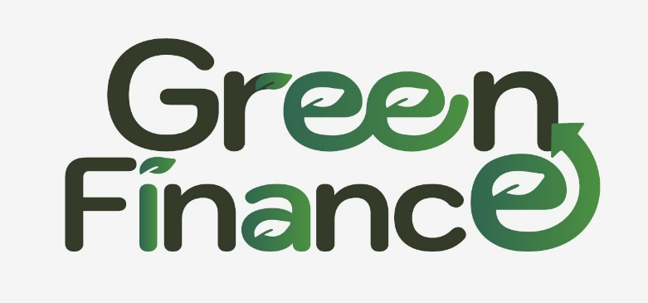
Funded by the European Union. Views and opinions expressed are however those of the author(s) only and do not necessarily reflect those of the European Union or the European Education and Culture Executive Agency (EACEA). Neither the European Union nor EACEA can be held responsible for them.

Advancing Higher Education for Sustainable Growth in Southeast Asia

Project Number: GREEN FINANCE · 101237817

Table of Contents
Table of Contents 4
Module Overview and How to Use This Reader 4
Climate-Related Financial Risks and Taxonomy 7
TCFD and TNFD Risk Assessment 13
Scenario Analysis and Climate Modeling 19
Carbon Metrics and Climate Value-at-Risk 24
Climate Stress Testing 32
ASEAN Climate Vulnerability 40
Practical Activity: ASEAN Case Study (Thailand Catastrophe Tail Risk) 46
Module 4 Assessment 49
Reading List and References 51
Key Terms and Acronyms 54
Acknowledgments 56

Module Overview and How to Use This Reader

What this module is about
Module 4 addresses climate-related financial risks and their management within financial institutions and investment portfolios. Participants learn to classify, measure, and manage climate risk using the TCFD and TNFD frameworks, NGFS scenarios, carbon metrics, Climate Value-at-Risk (CVaR), and stress testing. Every concept is applied to the ASEAN context, with balanced coverage of Vietnam, Thailand, and the Philippines.
Key concept: The Module 4 / Module 5 boundary. Module 4 is about risk management: identify, measure, and manage. Module 5 is about risk reporting: disclose and communicate. TCFD and TNFD appear in Module 4 as risk assessment frameworks (their Risk Management pillar)^{[23][24]}. Their disclosure and reporting requirements, together with ISSB S1/S2, SFDR, and CSRD, belong to Module 5.

Module parameters
Parameter | Value
ECTS | 0.8
Contact hours | 20 to 24
Duration | 4 weeks (full module)
Lessons | 6
Level | Foundation to PhD extension, with a quantitative lab
Assessment | 100 percent coursework (no final exam)
The 0.8 ECTS reflects total learner effort, roughly 20 to 24 contact hours over four weeks. Where a partner delivers only part of the module in a live session, this document holds all six lessons, so the lessons not presented live can be studied independently.

Length and the WP3 format rules
The WP3 format rules ask that a module document run to 30 to 40 A4 pages. The Module 4 submission document is 56 pages, and the deviation is declared here so that it travels with the document rather than only in the note accompanying it.
Module 4 is diagram-led. It teaches a taxonomy, a set of frameworks, a scenario apparatus, a metric stack, and a stress-testing pipeline, and each of those is a structure rather than a narrative. An earlier version held the page band by carrying only a fraction of the module’s figures, which left four of its six chapters to argue in prose alone while the figures themselves appeared in the participant handout. Restoring them is what the additional pages buy, and every figure states its provenance on its own face. If the band is a requirement rather than a guideline, a reduced version within it is available on request.

Learning outcomes
On completing this module, participants are able to:
- Classify climate-related financial risks using the physical, transition, and liability taxonomy, and map transmission channels into financial institutions.
- Apply the TCFD and TNFD frameworks for internal climate and nature risk assessment.
- Model climate scenarios using NGFS pathways and Integrated Assessment Models.
- Calculate financed emissions, carbon metrics, and Climate Value-at-Risk for portfolios.
- Design climate stress tests using NGFS scenarios and evaluate supervisory approaches.
- Evaluate ASEAN-specific climate vulnerabilities and adaptation finance mechanisms.
The outcomes rise in cognitive demand, from classifying and applying, through modelling and calculating, to designing and evaluating.

The six lessons at a glance
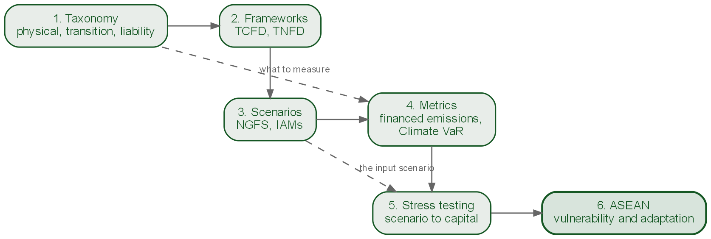
The six lessons and the order they depend on. The dashed edges are the two dependencies that matter most: Lesson 4 measures what Lesson 1 defines, and Lesson 5 consumes the scenarios Lesson 3 builds.
# | Lesson | Core focus | ASEAN case
1 | Climate-Related Financial Risks and Taxonomy | Taxonomy, transmission, materiality | Vietnam (Mekong)
2 | TCFD and TNFD Risk Assessment | Risk Management pillar, LEAP | Thailand (BOT)
3 | Scenario Analysis and Climate Modeling | NGFS pathways, IAMs | Philippines (typhoons)
4 | Carbon Metrics and Climate VaR | Financed emissions, WACI, CVaR | Vietnam (banking)
5 | Climate Stress Testing | Design, supervisory practice | Thailand (2011 floods)
6 | ASEAN Climate Vulnerability | Integrated assessment, adaptation | Philippines (resilience)
Narrative arc. Classify risk, then apply frameworks, then model futures, then measure exposure, then stress-test resilience, then apply everything to the ASEAN region. The sixth is the capstone that integrates all Module 4 concepts into a regional assessment.

How this reader is organised
The module is taught as six lessons and this reader holds them as six numbered chapters, one for one: Lesson 3 in a live session is Chapter 3 on these pages. The two words are not interchangeable here. Chapter always points at something in this reader, so a cross-reference you can turn to; lesson always means the taught session, which is why the teaching-notes boxes speak of lessons and timings while the body text speaks of chapters.
Each chapter follows the same shape: an opening line stating the question it answers, a short motivation, the learning objectives, the core concepts with worked detail, the relevant charts from the module chart set, an ASEAN case pointer, and a teaching-notes box for staff who will re-deliver the lesson. A consolidated reading list follows the chapters. Appendix A is a full ASEAN risk case study with a teaching structure; Appendix B is the module assessment with an answer key and grading rubric.
A note on the numbers. The worked examples and the country case studies in this reader use illustrative, representative figures chosen to demonstrate the methods. They are teaching constructions calibrated to plausible values, not audited results for specific named institutions, and should be cited as worked examples rather than as empirical findings about any particular bank or supervisor.
Teaching note. This reader doubles as a train-the-trainer guide. The teaching-notes boxes flag common misconceptions, suggested timing, and where each chart, dataset, or case fits in a live session. Adjust to your audience: emphasise the quantitative lab (Lessons 4 and 5) for analysts, and the taxonomy and ASEAN material (Lessons 1 and 6) for a policy audience.

Tools and methods
The module uses lectures for frameworks and theory, workshops for scenario exercises, a data lab in Python for metrics and stress tests, a stress-test design simulation, and guided self-study. Tools referenced across the lessons include Python (pandas, matplotlib, seaborn), the NGFS Scenario Explorer, a PCAF style financed-emissions calculator, and GIS for flood-zone mapping. Assessment is entirely coursework and is set out in full in Appendix B: fifteen multiple-choice questions covering all six lessons, with an answer key, plus one applied exercise built on the Appendix A case, marked against a four-dimension rubric.
Use of generative AI. Generative AI was used as a writing and research assistant in preparing this module. The tool was Claude (Anthropic), versions Opus 4.8 and Opus 5, used from July 2026 to the submission of this module on 11 September 2026. Its use was confined to idea generation and brainstorming, language editing, literature classification, coding assistance for the chart and data-processing scripts, and interactive literature searching. The authors specified and reviewed the content. Every cited source was checked against the original publication, and every figure states its provenance on its own face, distinguishing sourced values from derived values and from illustrative teaching assumptions. The authors remain fully responsible for the originality, accuracy, integrity, references, and conclusions of the material.

Climate-Related Financial Risks and Taxonomy
Before you can manage a risk, you must classify it.
This chapter is the Foundation-level entry point to Module 4. It assumes little prior finance or climate background, flags its advanced methods where they appear, and builds the vocabulary and the classification system on which every later chapter depends.

Learning objectives
After this chapter you will be able to:
- Classify climate risks into physical, transition, and liability categories with their sub-classifications.
- Map the transmission channels that link climate events to financial losses through credit, market, operational, and liquidity pathways.
- Distinguish short, medium, and long-term risk horizons and their implications for portfolio management.
- Apply double materiality (financial versus impact) to sectoral analysis across ASEAN economies.
- Assess Vietnam Mekong Delta climate vulnerability for a bank portfolio using a structured framework.

Why climate risk is a financial risk
In 2015 the then Governor of the Bank of England, Mark Carney, told an audience of insurers at Lloyd’s of London that climate change threatens financial stability, yet its worst impacts fall beyond the planning horizon of almost every actor in the room^{[9]}. Central banks plan two to three years ahead, politicians think in electoral cycles, and chief financial officers focus on quarterly earnings, while catastrophic climate impacts arrive in ten to thirty years or more. Carney called this mismatch the tragedy of the horizon: the costs fall on a future generation that the current generation has little direct incentive to address.
These are not hypothetical losses. Global economic losses from natural disasters reached roughly $250 billion in 2023 (Munich Re; insured losses around $95 billion)^{[17]}. The 2011 Thailand floods inundated industrial estates across the central provinces and disrupted supply chains far beyond Thailand; Typhoon Rai struck the Philippines in 2021. These are realized losses from today’s climate, before the additional warming projected for mid-century.
Key concept: Why climate risk is systemic. Unlike idiosyncratic credit or market risk, climate risk cannot be diversified away. It is correlated (a single typhoon hits thousands of borrowers at once), non-diversifiable (every sector and geography is exposed), non-linear (tipping points create sudden, irreversible losses), and forward-looking (historical data understates future exposure). These properties make it a systemic risk that affects the whole financial system simultaneously.

The taxonomy: physical, transition, liability
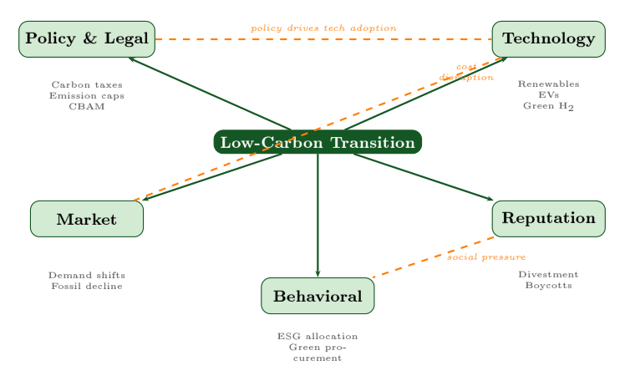
The five channels of transition risk.
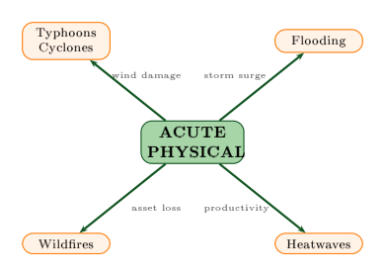
Acute and chronic physical risk are not two points on one scale. An acute hazard is an event; a chronic shift is a trend, and a trend cannot be insured against.
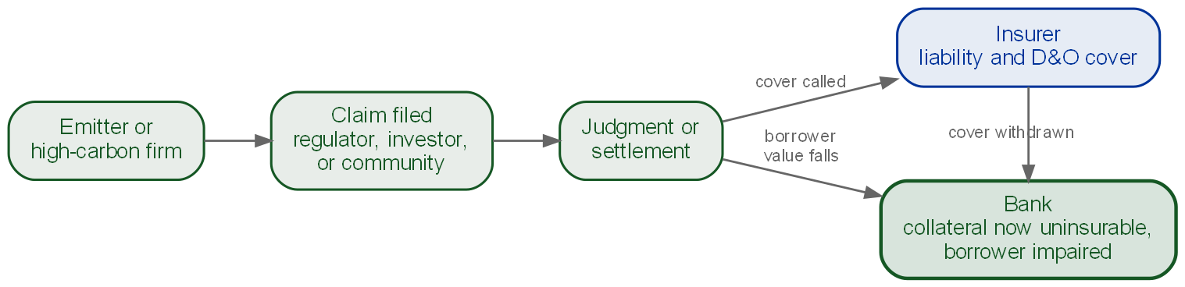
Liability risk is the only leg of the taxonomy that reaches the lender through a courtroom, and it hits the bank twice: the borrower is worth less, and the insurer withdraws the cover that made the collateral bankable.
Climate risk divides into three categories. Physical risks arise from the climate itself and split into acute hazards (event-driven: typhoons and cyclones, flooding, wildfires, heatwaves) and chronic shifts (slow-moving: sea-level rise, sustained temperature change, altered precipitation). Acute risks are insurable in principle but increasingly uninsurable in practice; chronic risks are largely uninsurable and require strategic portfolio adjustment.
Transition risks arise from the adjustment toward a lower-carbon economy. They run through five channels: policy and legal (carbon pricing, emission mandates, the EU Carbon Border Adjustment Mechanism phasing in from 2026^{[14]}), technology (renewables and electric vehicles rendering fossil assets obsolete), market (shifting demand and commodity volatility), reputation (divestment and boycotts), and behavioral (ESG-driven capital allocation). A useful distinction: physical risks increase with warming, while transition risks increase with policy ambition. An orderly transition carries low transition risk; a hot-house world carries low transition risk but extreme physical risk. Stranded assets (fossil reserves that cannot be burned, coal plants retired early, carbon-intensive real estate failing efficiency standards) are the sharpest expression of transition risk: Dietz et al. (2016) estimate the climate value at risk of global financial assets at $2.5 trillion in expectation, rising to $24.2 trillion at the 99th percentile^{[11]}.
Liability risks are the emerging third category. They cover litigation (suits against emitters or for failure to disclose), adaptation failure (liability for not adapting to known risks), and greenwashing (enforcement against misleading environmental claims). Setzer and Higham (2023) document 2,341 cases, a total that continues to grow^{[22]}; the 2021 Dutch court order requiring Shell to cut emissions 45 percent by 2030 shows that courts can impose binding financial consequences^{[16]}.
Climate risk taxonomy: categories, channels, and horizons
Category | Sub-type | Financial channel | Horizon
Physical | Acute | Insurance claims, collateral damage | Short
 | Chronic | Asset devaluation, yield decline | Medium to long
Transition | Policy and legal | Compliance costs, stranded assets | Short to medium
 | Technology | Asset obsolescence, capex needs | Medium
 | Market and reputation | Revenue decline, cost of capital | Short to medium
Liability | Litigation | Contingent liabilities, settlements | Medium to long
 | Adaptation failure | Damages, regulatory fines | Medium
 | Greenwashing | Fines, reputational loss | Short
This taxonomy follows Carney (2015), was refined by the TCFD (2017), and is extended to treat liability as a distinct category after Setzer and Higham (2023).

Transmission channels: how events become losses
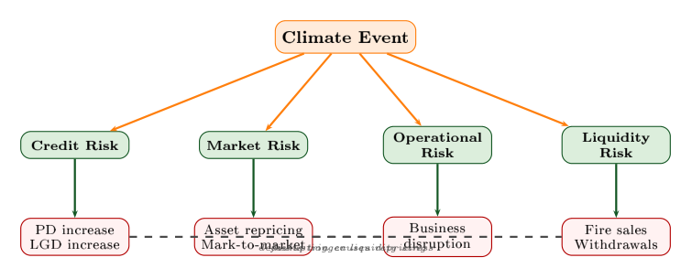
A single climate event reaches the balance sheet through four channels at once. The interaction between them is what makes the loss non-linear.
A climate event becomes a financial loss through one or more transmission channels, and these channels interact rather than acting independently. The four core channels are credit risk (borrower income or collateral falls, raising probability of default and loss given default), market risk (asset repricing and mark-to-market losses), operational risk (business disruption), and liquidity risk (fire sales and deposit withdrawals). Two further channels matter at system level: the insurance channel, which acts as a shock absorber in developed markets but barely exists across much of ASEAN, where the great majority of disaster losses are uninsured, and the asset management channel, through which portfolio repricing and coordinated divestment propagate losses.
Credit risk is the dominant channel for ASEAN banks, which dominate financial intermediation across the region. The critical insight is interaction: credit losses trigger liquidity stress, operational disruption forces market repricing, and these feedbacks produce the non-linear amplification that makes climate risk systemic. The 2011 Thailand floods illustrate all of this at once, as Thai banks faced simultaneous credit, operational, and liquidity stress.

Time horizons
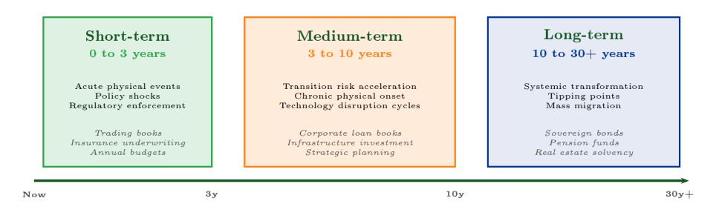
The tragedy of the horizon: the planning windows that govern trading books, loan books and pension funds, set against the timescale over which the risk arrives.
Climate risks operate across three timescales that mismatch traditional planning. Short-term risk (zero to three years) covers acute physical events, policy shocks, and regulatory enforcement, relevant to trading books and annual budgets. Medium-term risk (three to ten years) covers transition acceleration and the onset of chronic physical change, relevant to corporate loan books and infrastructure investment. Long-term risk (ten to thirty years and beyond) covers systemic transformation and tipping points, relevant to sovereign bonds, pension funds, and real-estate solvency. Because most actors plan one to five years ahead while the worst impacts arrive in ten to thirty years, the horizon mismatch is precisely Carney’s tragedy.

Materiality: single versus double
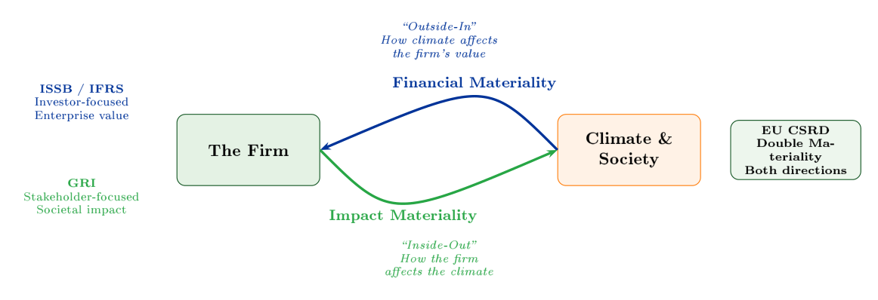
Financial materiality looks inward from the climate to the firm; impact materiality looks outward. The EU CSRD requires both directions at once.
Materiality decides which climate risks matter enough to require action, and three frameworks define it differently. Financial materiality is an outside-in view (how climate affects firm value), associated with the ISSB and IFRS. Impact materiality is an inside-out view (how the firm affects climate and society), associated with the GRI. The EU CSRD combines both as double materiality: a climate risk is material if it affects firm value or if the firm affects climate outcomes.
Key concept: Why double materiality changes ASEAN banking. Consider a Vietnamese coal-fired power plant. Its financial materiality may be low in the short term given strong domestic demand and government-backed purchase agreements, but its impact materiality is very high. Under double materiality both dimensions require disclosure and management. As ASEAN regulators adopt EU-aligned standards, the scope of material climate risk expands, so institutions that prepare now gain an advantage.

The quantitative core: climate-adjusted expected loss
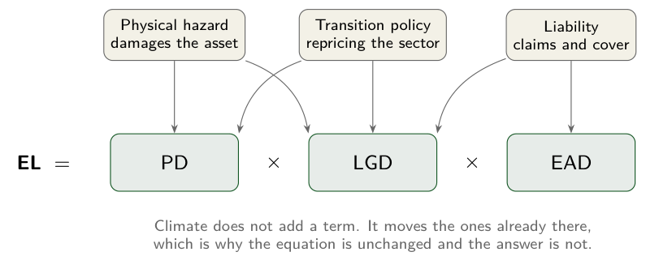
Climate adds no term to the expected-loss identity. It moves the three already in it, and each leg of the taxonomy moves a different pair.
The standard credit expected-loss identity extends to incorporate climate effects:
$$EL_{climate}=\underset{\text{climate-adjusted PD}}{\underset{⏟}{PD_{base} (1+ΔT⋅β_{climate})}}×\underset{\text{climate-adjusted LGD}}{\underset{⏟}{(LGD_{base}+ΔLGD_{physical})}}×EAD$$
where $ΔT$ is a temperature scenario, $β_{climate}$ is a sector-specific climate sensitivity (for example near 0.35 for agriculture, 0.25 for energy, 0.05 for technology), and $ΔLGD_{physical}$ captures additional collateral impairment. The point is that traditional models use historical default rates, whereas the climate-adjusted version uses scenario-based projections, shifting credit risk from what happened to what will happen.
Worked example: Mekong Delta agricultural portfolio under a plus 2.0 degrees C scenario
Metric | Baseline | Plus 2.0 deg C
Probability of default (PD) | 5.0% | 8.5%
Loss given default (LGD) | 60% | 65%
Exposure at default (EAD) | $300M | $300M
Expected loss | $9.0M | $16.6M
Climate VaR (added loss) | n/a | plus $7.6M (plus 84%)
With $PD_{adj}=0.05×(1+2.0×0.35)=0.085$ and $LGD_{adj}=0.60+0.05=0.65$, the expected loss rises from $9.0M to $16.6M, an 84 percent increase for the agriculture sector alone. Every input above is an illustrative teaching value, chosen to make the mechanism visible rather than measured from any real portfolio; vary them and the arithmetic follows.

Sectoral exposure
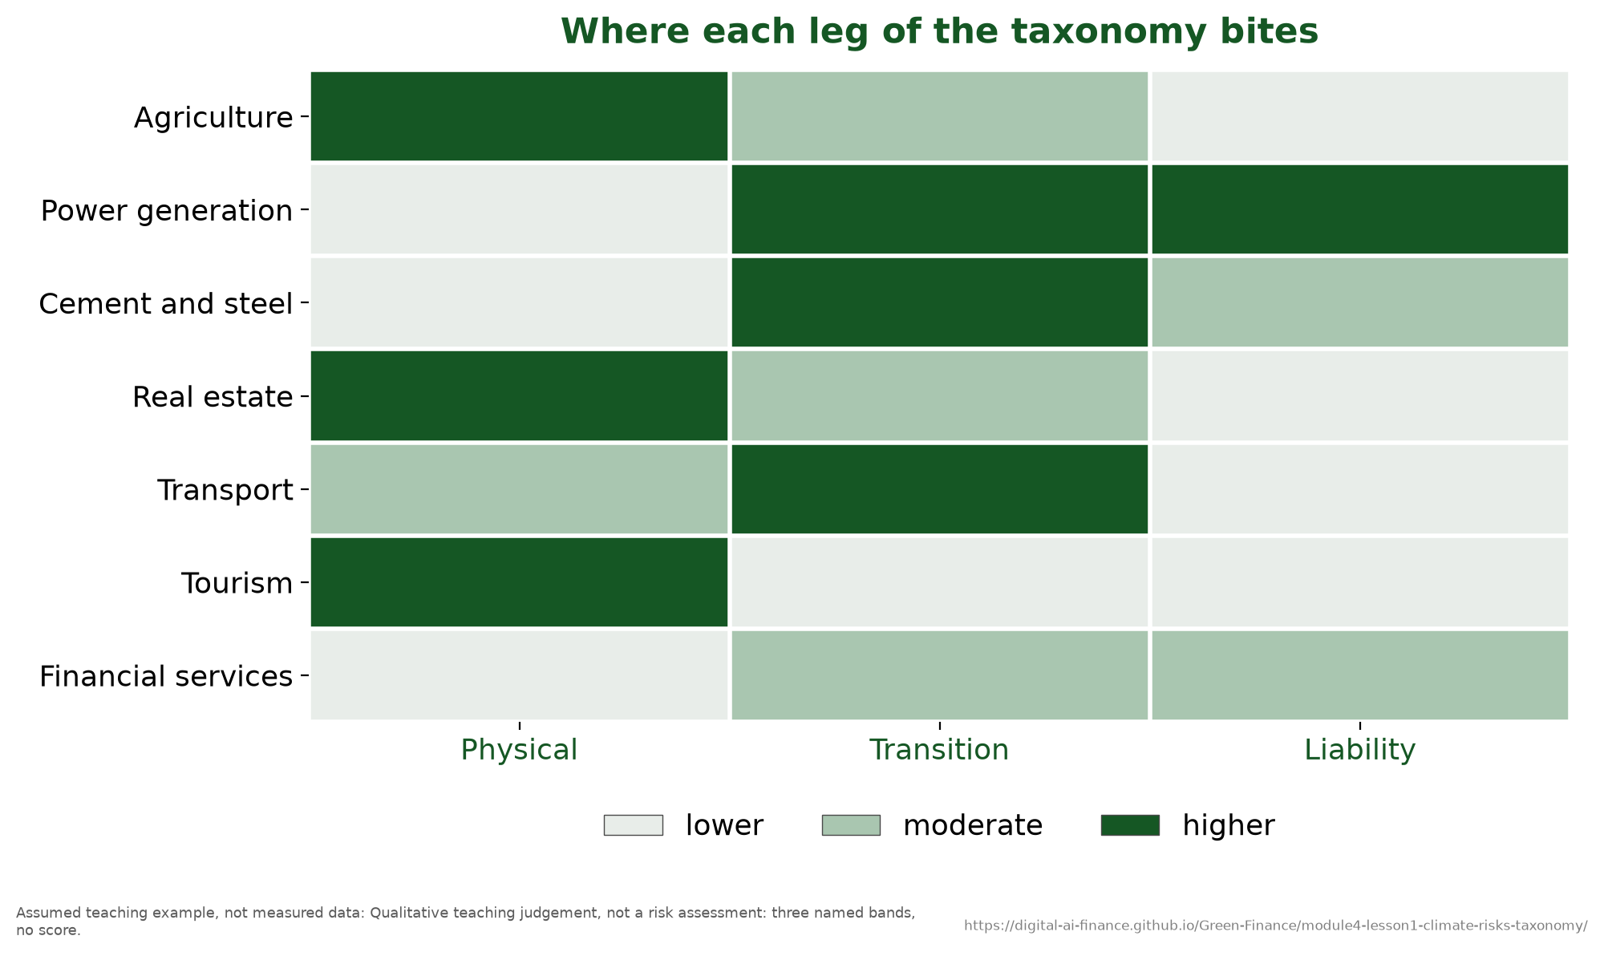
The qualitative pattern a sector scoring tool is built to quantify: three named bands, not a score.
Sectors carry different risk profiles, so a single climate score is misleading. Agriculture and fisheries are dominated by physical risk; energy is dominated by transition risk; real estate and transport face both. A practical tool is a heatmap scoring each sector from 1 to 5 across the acute physical, chronic physical, policy, technology, market, and litigation dimensions, then weighting by portfolio share to obtain a portfolio risk score. Banks concentrated in agriculture and energy carry the highest climate risk and should receive priority in risk management.
Case study: Vietnam’s Mekong Delta. The Mekong Delta is home to about 18 million people^{[26]}, produces the bulk of Vietnam’s rice and most of its aquaculture exports, and lies barely above sea level. Saltwater intrusion already reaches far inland in the dry season and is projected to advance further as the sea rises, placing a substantial share of the Delta at risk of inundation. For a bank with, say, 30 percent of its book in agriculture and 20 percent in real estate, the majority of the portfolio is directly exposed to physical risk across all three horizons. A useful contrast is the Philippines, where the dominant hazard is acute (about 20 tropical cyclones form in the region each year and 8 or 9 cross the country^{[21]}, recurring and insurable in theory), against Vietnam’s dominant chronic hazard (progressive and largely uninsurable). The two profiles call for different management strategies.
Key concept: PhD extension: climate risk as endogenous systemic risk. Battiston et al. (2017) show climate risk is not purely exogenous: financial-network structure creates endogenous amplification as shocks propagate through interbank exposures, portfolio overlaps, and fire-sale dynamics^{[4]}. An open research question is when network amplification exceeds the original exogenous loss, and how ASEAN interbank topology compares with EU networks in contagion vulnerability.
Teaching note. Anchor the whole lesson on the taxonomy table; every later lesson refers back to it, so it is worth time at the board. The most common misconception is that climate risk is just one more sector exposure that diversification handles; the systemic-risk box is the corrective. Allow about 50 to 60 minutes: 10 on motivation, 20 on the taxonomy and transmission, 10 on materiality, and 15 on the worked example. The worked example reproduces well as a live calculation; have participants vary $β_{climate}$ and $ΔT$ themselves. The visual anchors are the taxonomy table and the three diagrams: transmission channels for the mechanism, the horizon bands for Carney’s tragedy, and the two-way materiality arrows. This chapter has no quantitative charts, which begin in Chapter 4; the sector heatmap described above is an exercise for participants to build, not a figure supplied here.

Key takeaways
- Physical risk is acute plus chronic and rises with warming; transition risk runs through five channels and rises with policy ambition; liability risk (litigation, adaptation failure, greenwashing) rests on a case load that continues to grow.
- Four transmission channels (credit, market, operational, liquidity) interact rather than acting independently; credit is the dominant one for ASEAN banks, because banks dominate financial intermediation across the region and their balance sheets are loan-heavy.
- Double materiality (EU CSRD) is the direction of global convergence.
- The climate-adjusted expected-loss identity can raise expected loss materially for exposed sectors; historical models systematically understate climate risk.

TCFD and TNFD Risk Assessment
A framework is what stops every desk from managing the same risk its own way.
Chapter 1 gave you a taxonomy of climate risks. The board’s next question is operational: how do we systematically manage them? Without a common framework, every business line handles climate risk differently and risk management is ad hoc. This chapter introduces the two global frameworks that supply the structure: the TCFD for climate, and the TNFD for nature.

Learning objectives
After this chapter you will be able to:
- Explain the TCFD four-pillar framework and why the Risk Management pillar is its operational core.
- Apply the TNFD LEAP approach to identify nature-related financial risks.
- Integrate climate risk into Enterprise Risk Management (ERM).
- Score institutional TCFD risk-management maturity with a standardized rubric.
- Compare ASEAN regulatory approaches to TCFD implementation.
Key concept: The Module 4 / Module 5 boundary, restated. This chapter teaches TCFD and TNFD as risk assessment tools, that is, their Risk Management pillar and the processes for identifying and assessing risk. Their disclosure and reporting dimensions, together with ISSB S1/S2, belong to Module 5. Keep the distinction sharp: here we use the frameworks to manage, not to report.

Why standardized frameworks
Before 2017, climate disclosure was voluntary and inconsistent: each firm chose its own format and metrics, so investors could not compare across portfolios and regulators had no standardized supervisory tool. The Financial Stability Board created the Task Force on Climate-related Financial Disclosures (TCFD) in 2015 under Michael Bloomberg and Mark Carney, and the recommendations followed in 2017^{[23]}. The G7 committed to mandatory alignment in 2021; the TCFD was disbanded in 2023 with its monitoring role passing to the ISSB; and IFRS S2 began adoption across a growing number of jurisdictions in 2024. The lesson of that voluntary-to-mandatory arc is that disclosure without a mandate does not, on its own, change behaviour.

The TCFD four pillars
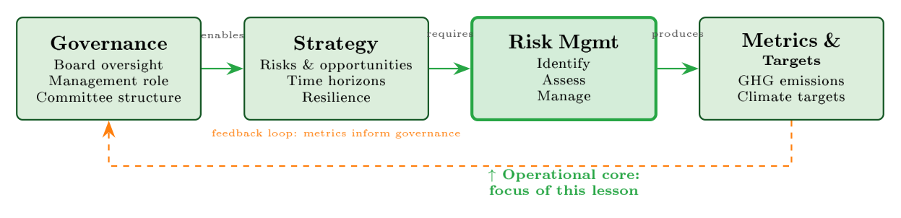
The four pillars of the TCFD framework; the Risk Management pillar is the operational core.
The TCFD organizes climate risk into four pillars that form a system rather than four independent disclosures. Governance assigns board and management responsibility. Strategy identifies risks and opportunities over short, medium, and long horizons and tests resilience under at least two scenarios. Risk Management is the operational core: identify, assess, manage. Metrics and Targets measure progress, including Scope 1, 2, and 3 emissions (Scope 3 covers financed emissions for banks), carbon intensity, and climate value at risk. Governance enables strategy, strategy requires risk management, and risk management produces the metrics that close the loop.
The TCFD four pillars as a system
Pillar | Core question | Key outputs
Governance | Who is responsible for climate risk? | Board mandate, committee structure, management roles
Strategy | How does climate affect our business? | Scenario analysis, resilience assessment, horizon mapping
Risk Management | How do we identify, assess, and manage climate risk? | Risk register, stress tests, risk-appetite thresholds, credit integration
Metrics and Targets | How do we measure and track progress? | GHG emissions, WACI, climate VaR, net-zero targets

The Risk Management pillar in depth
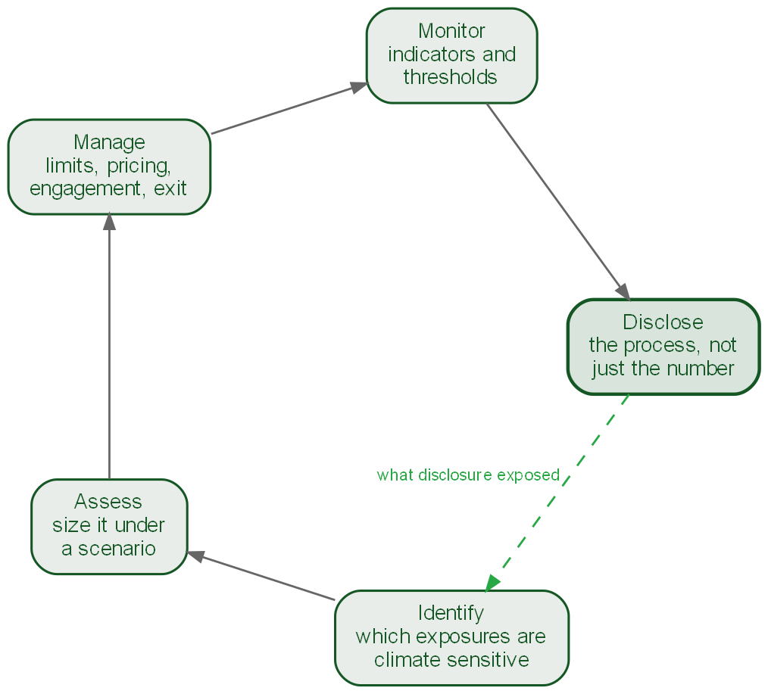
The standard risk cycle, closed by disclosure. Publishing a process is what exposes the exposures nobody had classified, which is why the last step returns to the first.
For risk professionals this is the pillar that matters most, because it is where day-to-day processes live. It has three sub-recommendations. Identify: map physical and transition exposures across business lines and geographies, run scenario screening, and keep a climate risk register inside the enterprise risk register rather than as a separate document. Assess: quantify likelihood and impact, prioritize against other risks with consistent scoring, and stress test under multiple NGFS scenarios, producing heatmaps and scenario-adjusted PD and LGD estimates. Manage: set risk-appetite thresholds, embed climate into credit approval, investment, and underwriting decisions, and monitor effectiveness. Governance and Strategy set direction and Metrics measure outcomes, but this pillar determines whether climate risk is actually managed.

Integrating climate into Enterprise Risk Management
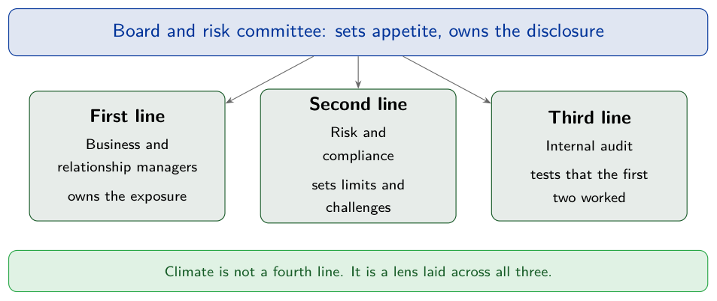
Climate is not a fourth line of defence. It is a lens laid across the three that already exist.
Climate risk should be embedded into the existing ERM rather than run as a separate silo. The principle is to use the same machinery: the same risk-appetite framework, the same risk register, the same committee structure, and the same escalation processes. In practice a bank adds, say, “physical flood risk to the mortgage portfolio” as a line item in its credit risk register, scored on the same likelihood-impact matrix, reviewed by the same committee, and bounded by the same appetite limits. The climate element is new; the infrastructure is existing.
The Basel Committee takes the same approach at supervisory level: its 2022 principles for climate-related financial risks run 1 to 12 on how banks should manage those risks and 13 to 18 on how prudential supervisors should review them^{[2]}.

From climate to nature: TNFD and LEAP
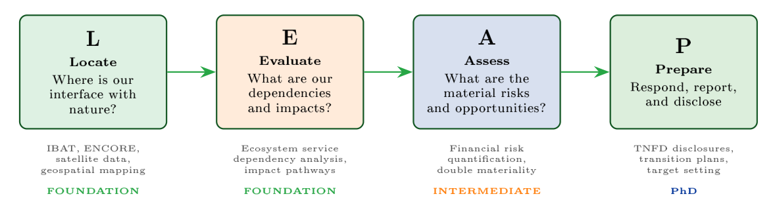
The TNFD LEAP process: Locate, Evaluate, Assess, Prepare.
Climate is only one dimension of environmental risk. The World Economic Forum has estimated that more than half of global GDP is moderately or highly dependent on nature, and Southeast Asia contains several of the world’s recognised biodiversity hotspots. The Taskforce on Nature-related Financial Disclosures published its v1.0 recommendations in September 2023, reusing the TCFD four-pillar structure and adding the LEAP approach: Locate the interface with nature, Evaluate dependencies and impacts, Assess material risks and opportunities, and Prepare to respond and report. Two risk types are central: dependency risk (reliance on ecosystem services such as water purification, pollination, and flood regulation) and impact risk (regulatory, reputational, and legal consequences of harming nature, for example under the EU Deforestation Regulation). Unlike carbon, which is globally fungible, nature risk is location-specific, so LEAP relies on geospatial tools (IBAT, ENCORE) and there is no single metric equivalent to tonnes of CO2 equivalent; candidates include Mean Species Abundance, the Biodiversity Intactness Index, and STAR.
TCFD and TNFD compared
Dimension | TCFD (climate) | TNFD (nature)
Established | 2015 FSB; recommendations 2017 | 2021; recommendations 2023 (v1.0)
Risk assessment | Scenario-based (NGFS) | Spatial, location-based (LEAP)
Key metric | tCO2e (globally fungible) | No single metric (MSA, BII, STAR)
Data maturity | High (GHG protocols established) | Low (spatial data gaps)
Regulatory status | Mandatory in many jurisdictions via ISSB S2 | Voluntary; early adoption
The two are complementary, not competing: deforestation accelerates climate change while climate change accelerates biodiversity loss, so integrated assessment is the goal.

Quantifying maturity
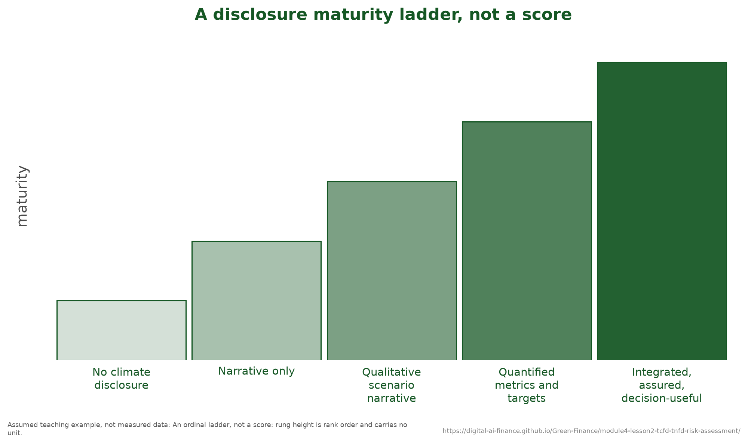
The stages a maturity rubric scores. Rung height is rank order and carries no unit.
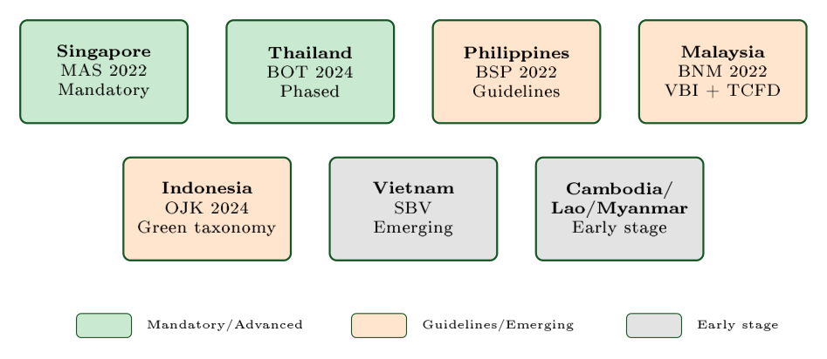
TCFD adoption across the ASEAN region.
A simple rubric scores risk-management maturity on four dimensions (identify, assess, manage, integrate), each from 0 to 3, for a total from 0 to 12: 0 to 3 absent, 4 to 6 basic, 7 to 9 developing, 10 to 12 advanced. Applying it to a hypothetical Thai commercial bank gives identification 2, assessment 1 (qualitative only, limited scenario work), management 2 (sector policies but no portfolio steering), and integration 1 (reported separately from the main ERM), a total of 6 out of 12, that is developing. The two highest-value moves are to implement NGFS scenario analysis (raising assessment) and to put climate risk into the board risk-appetite statement (raising integration).
Case study: Bank of Thailand, from the 2011 floods to a TCFD mandate. Thailand’s 2011 floods caused about $46.5 billion^{[25]} in economic damage, inundated industrial estates across the central provinces, pushed non-performing loans sharply higher in the affected areas, and cut national output for the rest of the year. The episode showed that climate events are core financial risks, not externalities. The Bank of Thailand responded with a phased TCFD mandate: domestic systemically important banks first (2024), then all commercial banks (2025), then specialized institutions (2026 onward). A three-country comparison is instructive: Thailand mandates on a phased basis driven by its flood experience, Singapore (MAS, 2022) mandates uniformly driven by financial-centre competitiveness, and Vietnam (SBV) remains at an emerging, largely voluntary stage despite comparable physical exposure. Adoption across ASEAN tracks financial-centre development and disaster experience more than raw vulnerability.
Key concept: PhD extension: the awareness-action gap. Krueger, Sautner, and Starks (2020, Review of Financial Studies) surveyed 439 institutional investors^{[15]} and found that many of them, especially the larger, longer-horizon and ESG-oriented ones, treat risk management and engagement rather than divestment as the better response to climate risk^{[15]}. Read against how slowly portfolio allocations actually moved, that is the awareness-action gap, and it is part of why disclosure went from voluntary to mandatory under ISSB S2. An open question is whether the gap has narrowed since mandatory regimes took effect, and how large it is for ASEAN investors specifically. A parallel frontier is TNFD data: biodiversity assessment starts from roughly where carbon accounting stood around 2005.
Teaching note. The single most important teaching point is the M4/M5 boundary, because participants routinely conflate “assessing” a risk with “disclosing” it. Spend time on the Risk Management pillar (identify, assess, manage) and the ERM-integration idea that the climate element is new but the infrastructure is existing; this is the practical heart of the lesson. The Thai-bank scoring rubric works well as a live exercise: have participants score their own institution and name the two highest-value actions. Budget about 50 minutes: 15 on the four pillars, 15 on the Risk Management pillar and ERM, 10 on TNFD and LEAP, and 10 on the scoring exercise and the Bank of Thailand case.

Key takeaways
- TCFD’s four pillars are a system; the Risk Management pillar (identify, assess, manage) is the operational core.
- Climate risk belongs inside the existing ERM: same appetite, register, committee, and escalation.
- TNFD extends the structure to nature through the location-based LEAP approach, distinguishing dependency from impact risk.
- Maturity can be scored 0 to 12; most ASEAN institutions are at the basic-to-developing stage, with scenario analysis and board-level integration the highest-value next steps.

Scenario Analysis and Climate Modeling
Nobody can forecast the climate. Everybody can be asked what if.
Chapter 1 told you what the risks are and Chapter 2 told you how to assess and disclose them. This chapter answers the board’s harder question: what if? What happens to the portfolio if carbon prices triple by 2035, or if warming reaches three degrees? Scenario analysis is the discipline that turns an abstract climate pathway into a concrete portfolio loss number, and it is the engine behind the TCFD Strategy pillar’s resilience requirement.

Learning objectives
After this chapter you will be able to:
- Explain why scenarios are not predictions and what deep uncertainty means.
- Describe the seven NGFS reference scenarios and select the ones that matter for ASEAN.
- Trace the five-stage transmission chain from a climate pathway to portfolio losses.
- Calibrate sectoral PD and LGD shocks from scenario variables.
- Outline what Integrated Assessment Models do and why damage-function choice matters.

Why scenarios, not predictions
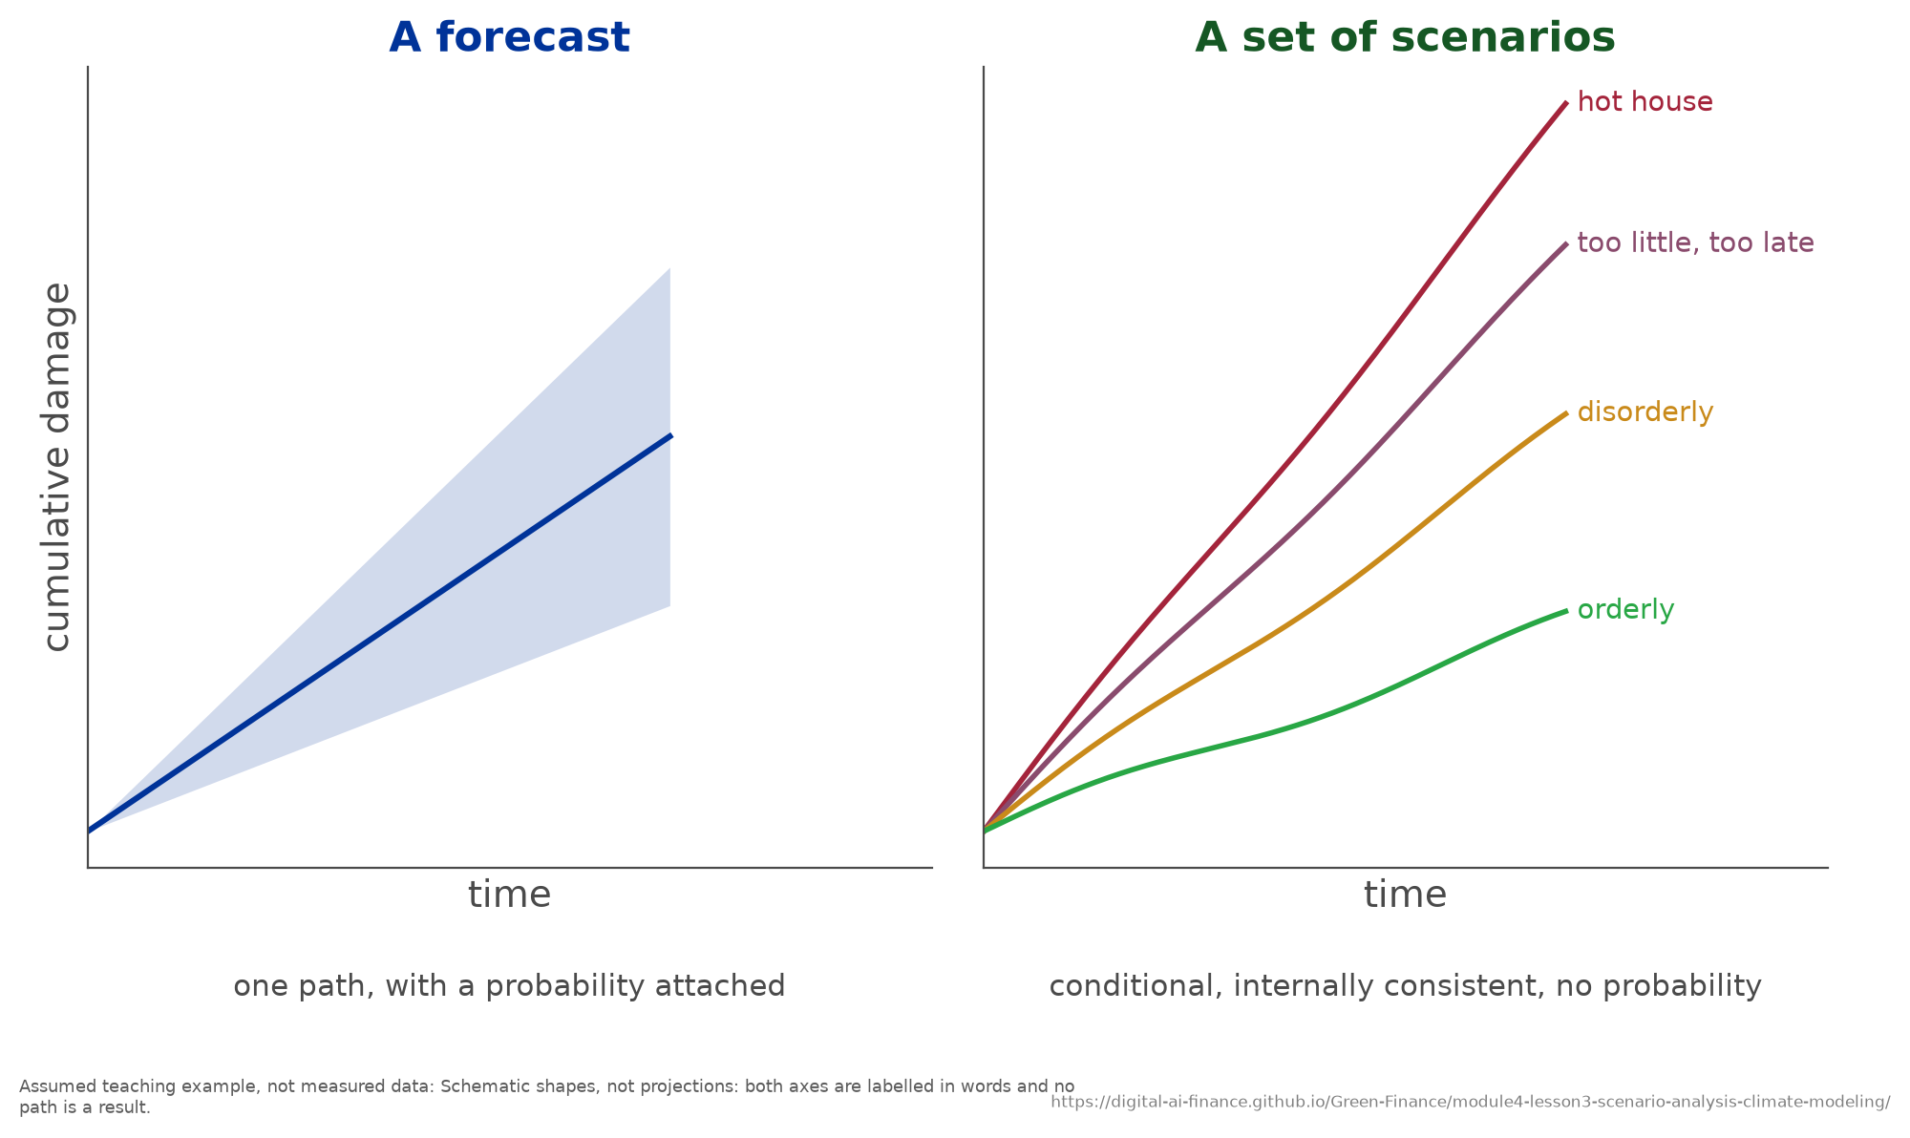
A forecast is one path carrying a probability; a scenario set is a family of conditional paths carrying none. Supervisors ask for the second and are regularly sent the first.
Predictions fail for climate because the system has non-linear dynamics and tipping points, because outcomes depend on policy choices not yet made, and because we face deep uncertainty rather than measurable risk. Risk has known probabilities; deep uncertainty means the probability distribution itself is unknown. Scenarios respond to this by offering structured explorations of plausible futures: internally consistent “what if” stories about climate, policy, and technology that let an institution stress test against several pathways and look for vulnerabilities that persist across all of them. The goal is robust strategy, not a point forecast. Climate scenarios evolved from the purely scientific (SRES in 2000, RCPs in 2011), through socioeconomic integration (SSPs in 2017), to financial-sector operationalization in the NGFS scenarios.

The NGFS scenarios
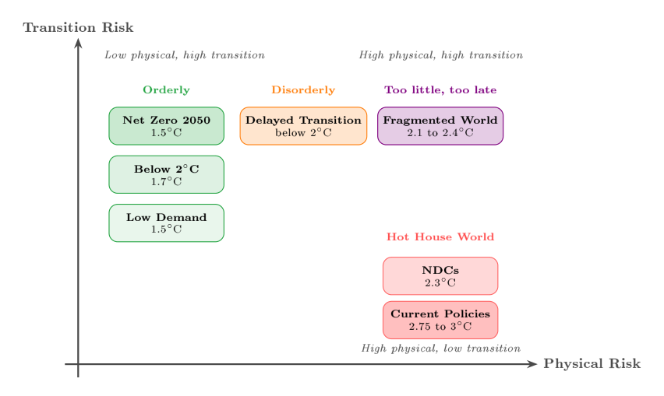
The NGFS scenario framework across physical and transition risk.
The Network for Greening the Financial System, founded in 2017 at the Paris One Planet Summit^{[20]} and now spanning central banks and supervisors worldwide (including the BSP, BOT, SBV, and BNM in ASEAN), publishes the de facto standard climate scenarios for financial supervision, with a free open-access database, wide sectoral coverage, regional detail for Southeast Asia, and several IAM backends. The current release, results version 5.0 of November 2024, provides seven reference scenarios in four categories: orderly transition, disorderly transition, hot world (Hot House World in earlier vintages, and the term used throughout this module), and too little, too late^{[19]}. The set is revised roughly every year, so a scenario table without a version number cannot be checked: Divergent Net Zero, in the 2022 vintage, was retired in Phase IV and replaced by Fragmented World and Low Demand.
The seven NGFS scenarios, results version 5.0 of November 2024. Every value here is from that release. Carbon prices and GDP impacts are deliberately not tabulated: see the note below.
Scenario | Category | Temperature (2100)
Net Zero 2050 | Orderly | 1.5 deg C
Below 2 deg C | Orderly | 1.7 deg C
Low Demand | Orderly | 1.5 deg C
Delayed Transition | Disorderly | below 2 deg C
Fragmented World | Too little, too late | 2.1 to 2.4 deg C
NDCs | Hot House World | 2.3 deg C
Current Policies | Hot House World | 2.75 to 3 deg C
Carbon prices and GDP impacts are not tabulated here, and the omission is the teaching point. They are model outputs, not scenario definitions: the same scenario run through a different integrated assessment model gives a different number, and the spread is wide enough that a single tabulated value misleads. For Net Zero 2050 the modelled global carbon price reaches 500 to 1,250 US$2010 per tonne by 2050, a two-and-a-half-fold spread across models for one scenario in one year^{[18]}. Quote a range and its model, or pull the pathway live from the NGFS Scenario Explorer; do not quote a slide.
Key concept: Why ASEAN is the inverse of developed markets. There is no zero-cost scenario: orderly transitions accept high transition costs now to limit physical damage later, while a hot-house world avoids transition costs but courts catastrophic physical damage, and disorderly paths get the worst of both. For developed markets, heavy in fossil assets, the Disorderly scenario is usually worst (transition risk). For ASEAN, with tropical, coastal, agriculture-dependent economies and very low insurance penetration, the Hot House World is worst, typically producing losses well above those of Disorderly. The fourth category sharpens this rather than softening it: Fragmented World, the too-little-too-late case, assumes delayed and regionally divergent policy, so it carries high physical and high transition risk at once. For a region that is physically exposed and also trade-exposed to other countries’ carbon policy, that is the more plausible adverse path, and it belongs in an ASEAN stress test alongside Hot House World. Bolton et al. (2020) call these climate tail risks “green swans”: unlike black swans they are expected to materialize, yet their timing and magnitude remain deeply uncertain^{[7]}.
The IEA’s energy scenarios (Net Zero Emissions, Announced Pledges, Stated Policies) complement the NGFS set: use NGFS for portfolio-level stress testing and IEA for energy-sector deep dives.

The transmission chain
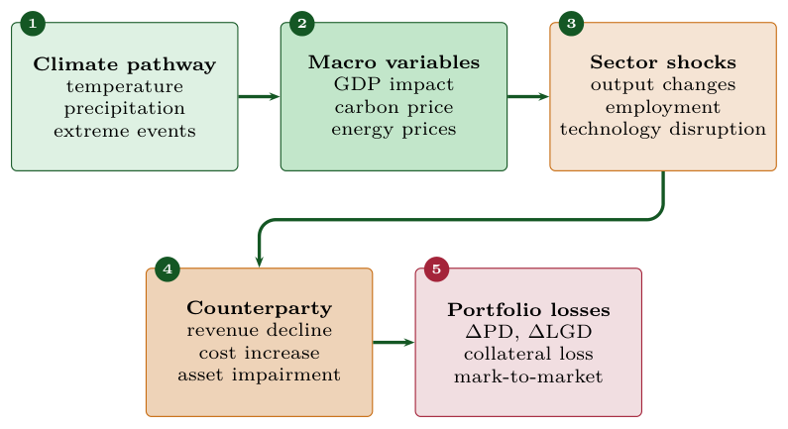
From climate pathway to portfolio losses. Each stage is a model, so each adds its own uncertainty to everything downstream of it.
Every scenario analysis follows the same five-stage chain, and each stage adds model uncertainty:
- Climate pathway: temperature, precipitation, extreme-event frequency.
- Macro variables: GDP impact, carbon price, energy prices.
- Sector shocks: output, employment, technology disruption.
- Counterparty: revenue decline, cost increase, asset impairment.
- Portfolio losses: changes in PD and LGD, collateral loss, mark-to-market losses.
As an ASEAN illustration, Philippine agriculture under a hot-house pathway runs from plus 2.5 degrees C, through a GDP deviation of about minus 8 percent and a roughly 15 percent decline in rice yield, to a non-performing-loan rate that climbs from 8 percent to about 16 percent. The chain is the core analytical structure: master it and any scenario becomes tractable. The minimum inputs are six variables: carbon price, GDP growth, temperature pathway, energy mix, technology cost, and policy stringency.

Calibrating sectoral shocks
Scenario variables become portfolio numbers through simple, transparent calibrations. The probability-of-default shock scales GDP by a sector sensitivity:
$$ΔPD_{sector}=- β_{sector}×ΔGDP_{scenario},$$
in percentage points, with the minus sign because a fall in output raises defaults. For Philippine agriculture under a hot-house pathway with $ΔGDP=-8\%$ and $β_{agriculture}=1.5$, this gives a rise of 12 percentage points in the default probability. The loss-given-default adjustment captures the uninsured share of physical damage:
$$LGD_{climate}=LGD_{base}+(1-\text{insurance coverage})×\text{physical damage rate},$$
so an agricultural loan with $LGD_{base}=45\%$, 30 percent insurance, and a 25 percent damage rate has $LGD_{climate}=45\%+0.70×25\%=62.5\%$. For ASEAN portfolios this LGD adjustment is often the single largest impact, larger than the PD shift. Aggregating across a sample Philippine bank (agriculture 25 percent, manufacturing 20 percent, real estate 15 percent, energy 10 percent, services 30 percent) under a disorderly scenario gives a portfolio-weighted PD increase of about 5.55 percentage points, which on a $2 billion book at the 62.5 percent climate-adjusted LGD above implies roughly $69 million in additional expected credit losses. Note that the LGD belongs in that step: a PD rise multiplied by exposure alone gives the amount entering default, and only the loss identity of Chapter 1 turns it into a loss.

Quantifying uncertainty
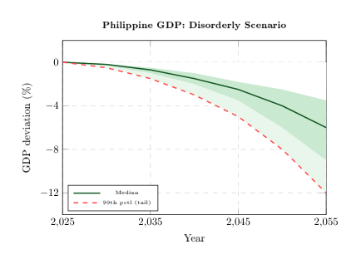
A fan chart says what a single line cannot: the central path is a median of simulations, and the band widens with the horizon because each stage compounds the uncertainty of the one before.
Because the future is a distribution rather than a path, results are best shown as Monte Carlo fan charts: the central line is the median of many simulated paths, not a forecast, and the shaded bands (for example the 25th to 75th and 10th to 90th percentiles) widen over time as uncertainty compounds. Risk management should focus on the tails, not the centre; the width of the fan is the message.

Under the hood: models, budgets, and damages
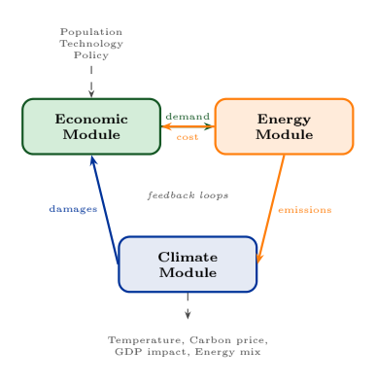
The three coupled modules of an Integrated Assessment Model. The feedback arrows are why a scenario cannot be read off any one of them.
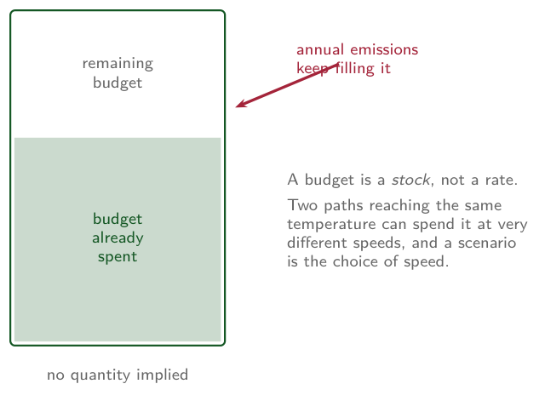
A carbon budget is a stock, not an annual allowance, so two pathways reaching the same temperature differ in how fast they spend a fixed quantity. No quantity is shown: the contested part is its size, and the teaching point is its shape.
The numbers behind every NGFS scenario come from Integrated Assessment Models (IAMs), which couple an economic, an energy, and a climate module with feedback between them.
The main models are DICE (useful for teaching but too aggregated for portfolios), REMIND-MAgPIE (best ASEAN granularity), GCAM, and MESSAGEix-GLOBIOM; because they make different structural assumptions, the same scenario name can yield different numbers. Two relationships are central. The carbon budget constraint, t​Et≤B1.5, holds cumulative emissions below the budget consistent with a temperature limit; on current IPCC estimates that budget is exhausted within roughly a decade at present emission rates, so every year of delay sharpens the required pace of transition. The damage function, often written $D(T)=αT^{2}/(1+βT^{2})$, translates temperature into GDP loss, and its calibration is the single most consequential assumption in any IAM: at the same four degrees of warming, published estimates of the GDP loss differ several-fold depending on whose damage function is used. That spread, not any one figure, is the point.
Key concept: PhD extension: discount rates and the limits of IAMs. The Stern-Nordhaus debate turns on the discount rate in the Ramsey equation $r=δ+ηg$: Stern’s low rate implies a high social cost of carbon and urgent action, while Nordhaus’s higher rate implies a much lower cost and gradualism. The resulting several-fold difference in the social cost of carbon is driven by an ethical choice about how much to weigh future generations, not by any disagreement about the physics. Weitzman (2009) argues that fat-tailed catastrophic risk should dominate cost-benefit analysis, and Pindyck (2013) warns that IAMs create an illusion of precision. For ASEAN the discount-rate debate is somewhat less binding, because physical damages arrive in the near term and are barely discounted at any plausible rate. Use IAMs with awareness of their limits, not as truth; the alternative is no quantitative framework at all.
Case study: Philippines typhoons and the cubic wind-damage law. About 20 tropical cyclones form in the Philippine region each year and 8 or 9 cross the country^{[21]}, and cyclone intensity is projected to rise as the ocean warms; Super Typhoon Haiyan (2013) remains the benchmark event, and the great majority of Philippine disaster losses are uninsured. The decisive physics is that wind damage scales with the cube of wind speed, $Damage∝v^{3}$, so a quarter more intensity implies roughly twice the damage (${1.25}^{3}≈1.95$). This is why a “moderate” climate projection becomes an extreme financial shock: modelled agricultural NPLs rise from 8 percent today to about 15.6 percent under a hot-house pathway. From 2024 the BSP mandates NGFS-aligned stress testing for all universal and commercial banks, and sensible policy responses include climate-adjusted capital buffers, crop-insurance loan conditions to cut LGD, and concentration caps on typhoon-corridor lending.
Teaching note. The two ideas that reliably change how participants think are the ASEAN inversion (hot-house, not disorderly, is the worst case here) and the cubic wind-damage law (a small intensity change nearly doubles losses); lead with both. Walk the five-stage transmission chain once slowly, then have participants reproduce the Philippine PD and LGD calculations themselves, since the arithmetic is simple and memorable. If time is short, the IAM, carbon-budget, and discount-rate material is the natural part to assign as self-study from this reader. Pulling a pathway live from the NGFS Scenario Explorer makes a good demonstration. Budget about 55 minutes: 10 on scenarios versus predictions, 15 on the NGFS set and the ASEAN inversion, 20 on the transmission chain and calibration, and 10 on the Philippines case.

Key takeaways
- Scenarios explore plausible futures under deep uncertainty; they are not predictions.
- The NGFS provides seven reference scenarios in four categories (version 5.0, November 2024); for ASEAN the Hot House World is the worst case on physical damage, the inverse of developed markets, and Fragmented World is the too-little-too-late case that is high on both.
- The five-stage transmission chain links climate pathway to portfolio loss; calibrate with $ΔPD=β ΔGDP$ and the uninsured-damage LGD adjustment.
- Damage-function and discount-rate choices move IAM results by factors of three to five, so always report sensitivity ranges.

Carbon Metrics and Climate Value-at-Risk
You cannot manage what you cannot measure.
Scenario analysis tells you what the world might do; carbon metrics tell you how much your own portfolio is exposed. This chapter therefore builds the measurement toolkit (GHG scopes, financed emissions, WACI, data-quality tiers, alignment metrics) and then turns those measurements into a financial loss number through Climate Value-at-Risk (CVaR). The recurring lesson, made concrete in the Vietnam case, is that where the carbon is and where the financial risk is are not the same place.

Learning objectives
After this chapter you will be able to:
- Distinguish Scope 1, 2, and 3 emissions and compute financed emissions with the PCAF formula.
- Calculate and benchmark a portfolio’s Weighted Average Carbon Intensity (WACI).
- Read PCAF data-quality tiers and state the ASEAN data reality.
- Decompose Climate VaR into physical and transition components and compute each.
- Explain the carbon premium and why exposure size can dominate carbon intensity.

Financed emissions: where a bank’s carbon actually is
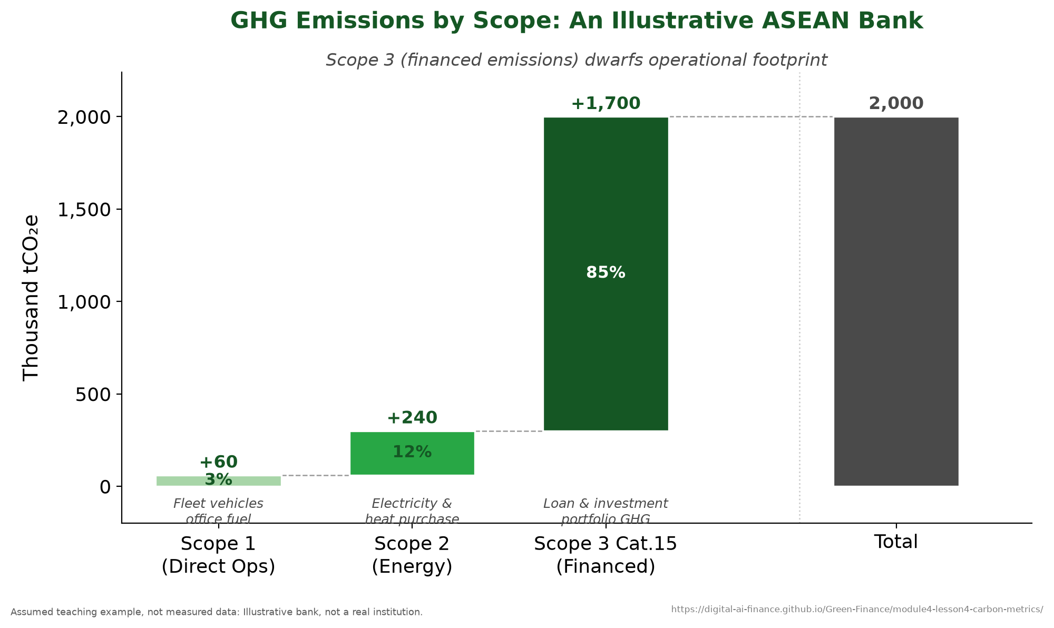
GHG emissions by scope: the financed-emissions waterfall.
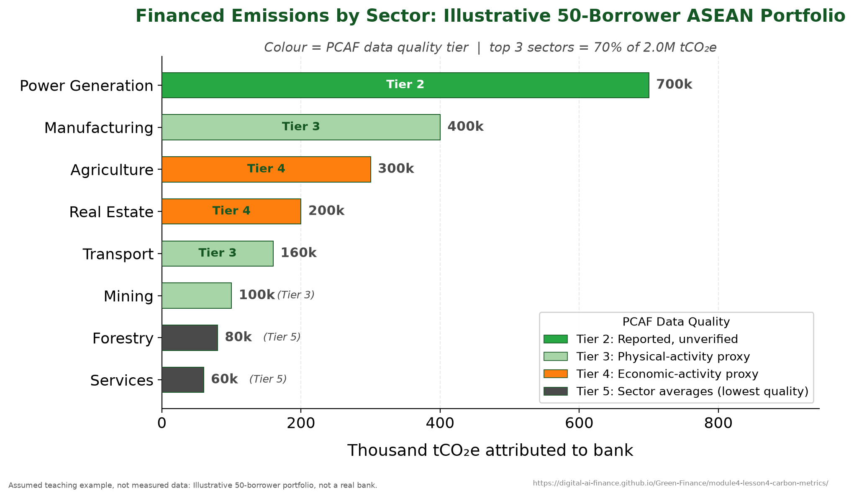
Attributing a borrower’s emissions to the lender.
For a bank, the emissions that matter are almost none of its own. CDP reports that the emissions associated with financial institutions’ investing, lending, and underwriting activities are on average more than 700 times their direct emissions^{[8]}. The lending and investment portfolio (Scope 3, Category 15, the financed emissions) therefore dominates the inventory so completely that Scope 1 and Scope 2 are rounding errors beside it. The waterfall below deliberately understates that ratio, because at the true one the operational bars would be invisible. This is why the Partnership for Carbon Accounting Financials (PCAF) exists: to standardize how financed emissions are computed. The PCAF attribution formula is
$$FE_{i}=\frac{Outstanding_{i}}{EVIC_{i}}×Emissions_{i},$$
where $Outstanding_{i}$ is the bank’s loan to borrower $i$, $EVIC_{i}$ is the borrower’s Enterprise Value Including Cash (the attribution factor), and $Emissions_{i}$ is the borrower’s absolute emissions. For a Vietnamese steel company with a $50M loan, $500M EVIC, and 200,000 tCO2e of emissions, the bank is attributed ${50}/{500}×200,000=20,000$ tCO2e. The attribution factor ensures each lender is responsible only for its share.

Weighted Average Carbon Intensity
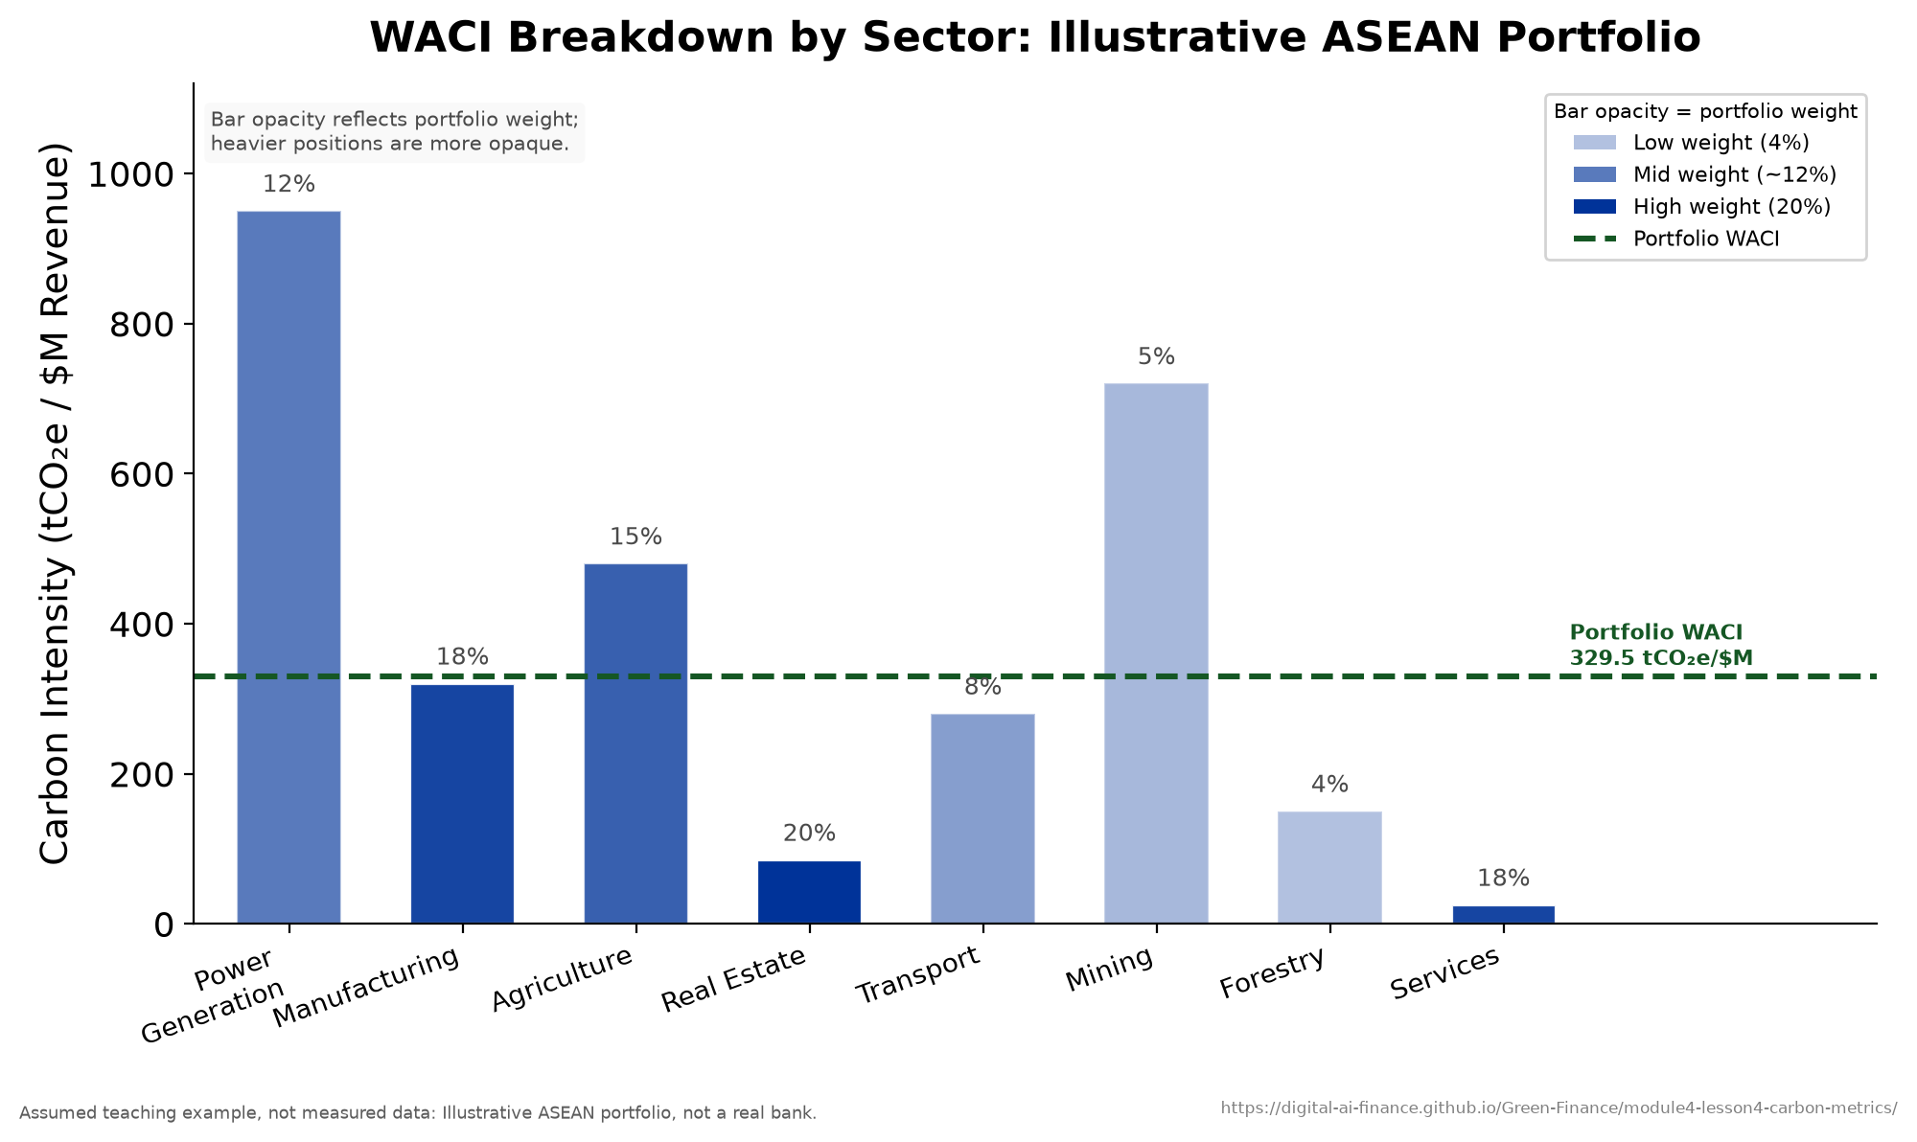
Portfolio WACI broken down by sector.
WACI is the portfolio carbon metric the TCFD recommends, and the most widely reported one, because it normalizes for company size:
WACI=i​wi×EmissionsiRevenuei,
where $w_{i}$ is the portfolio weight and the ratio is carbon intensity in tCO2e per million dollars of revenue. A three-company portfolio of a power utility (40 percent weight, intensity 800), a manufacturer (35 percent, 200), and a tech firm (25 percent, 15) has $WACI=0.40×800+0.35×200+0.25×15≈394$ tCO2e per million dollars, and the utility alone contributes about 81 percent of that despite being 40 percent of value. That 394 is this illustration’s own arithmetic, not a measured regional average. Coal-heavy power generation does push ASEAN portfolio intensities above global benchmarks, but the benchmark to compare against should be taken from the reporting institution rather than from a worked example.

Data quality and alignment
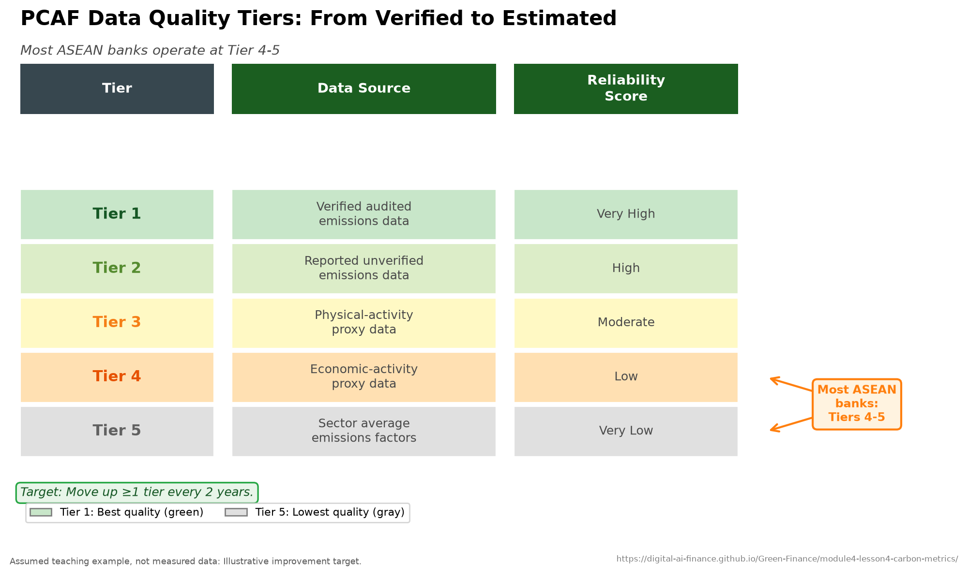
PCAF data-quality score tiers.
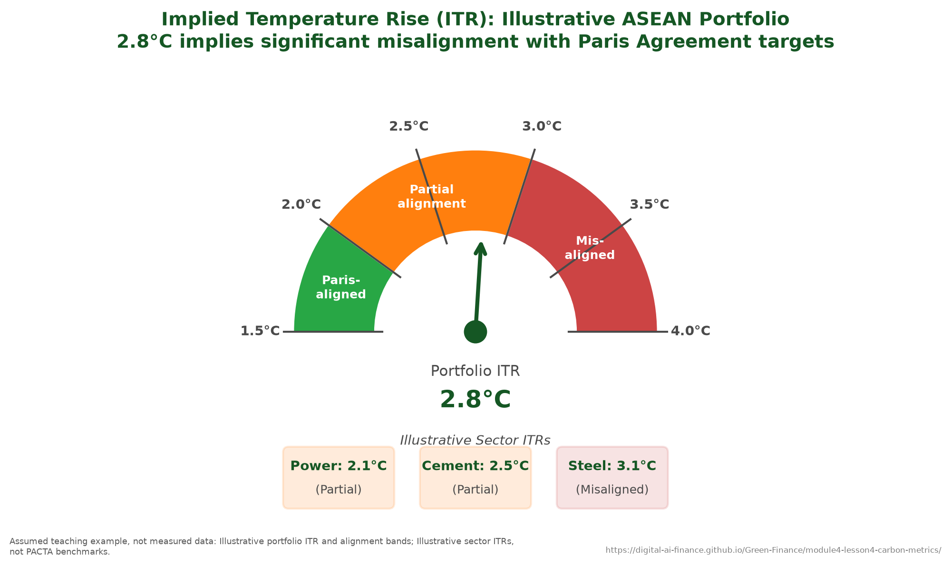
Implied Temperature Rise: the portfolio alignment gauge.
PCAF scores data quality on a five-tier scale that runs from verified audited emissions at the top tier to sector-average proxies at the bottom. The tier is not bookkeeping: it is the honest width of the number. A portfolio metric built mostly from sector averages is a different kind of object from one built on audited data, even when both print to three significant figures. The ASEAN reality is that verified corporate emissions reporting is far less common than in the EU, Scope 3 reporting is rarer still, and most bank calculations therefore rest on the proxy tiers. The right response is to report the data-quality tier and the uncertainty range alongside every metric rather than hide them behind a decimal point. Three complementary alignment tools answer different questions: PACTA tests whether a portfolio sits on a Paris-consistent pathway, the Transition Pathway Initiative scores company governance and trajectory, and the Science Based Targets initiative validates company targets. Combined into a single Implied Temperature Rise, a carbon-heavy ASEAN bank portfolio typically implies warming well above the Paris goal.

Climate Value-at-Risk
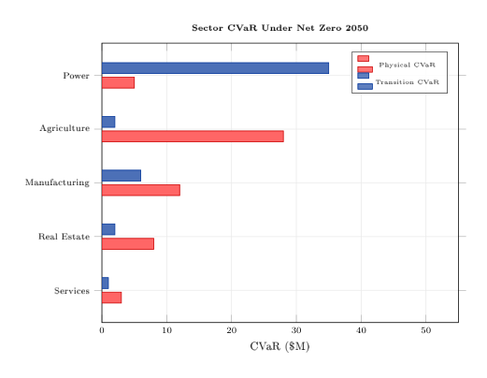
Climate VaR as a decision tree rather than a formula. The branches compound, which is why a CVaR figure without its method is uninterpretable.
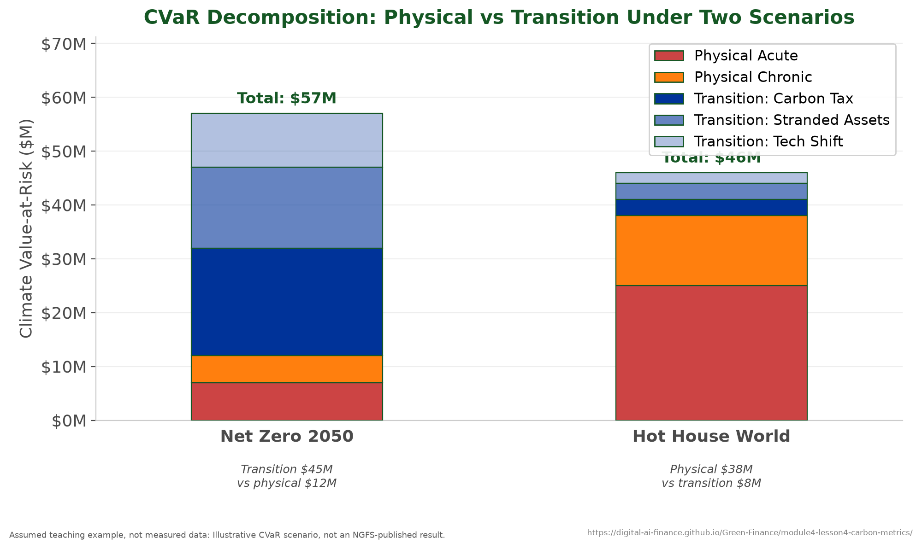
Climate VaR decomposed into physical and transition components.
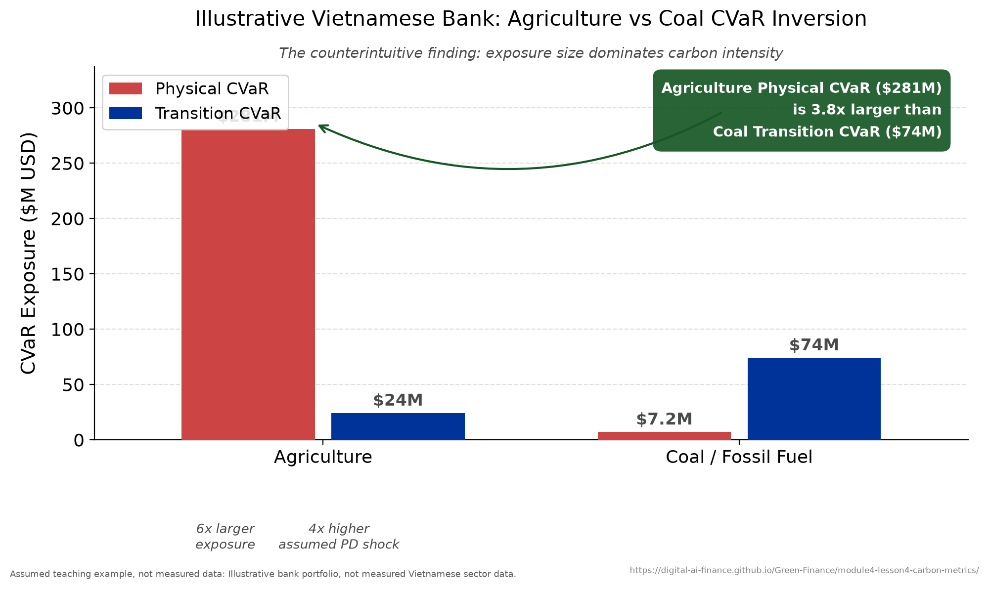
The Vietnam agriculture-coal Climate VaR inversion.
CVaR translates all of the above into a loss number.
It is the expected loss of portfolio value under a specified climate scenario,
$$CVaR=Portfolio_{t_{0}}-E​\left[Portfolio_{t_{T}}∣Scenario\right],$$
so a $2 billion portfolio expected to be worth $1.62 billion under a hot-house 2050 pathway carries a CVaR of $380 million, or 19 percent. It differs from standard VaR in three ways: it is scenario-conditional rather than probabilistic, it has a multi-decade horizon, and it decomposes into physical and transition components. Operationally,
CVaR=i​Exposurei×ΔPDi×LGDi,
evaluated separately for the physical channel (climate-adjusted default and uninsured collateral loss) and the transition channel (carbon pricing, stranded assets, technology displacement). A Vietnamese rice borrower with $10M exposure, default probability rising from 5 to 12 percent and LGD of 65 percent contributes $\$10\text{M}×7\%×65\%=\$455,000$ of physical CVaR; a coal borrower with $20M exposure, default probability rising from 3 to 18 percent under a $75 carbon price and LGD of 55 percent contributes $\$20\text{M}×15\%×55\%=\$1.65\text{M}$ of transition CVaR.
The decomposition shows that the scenario choice determines which channel dominates, and it reverses them: under Net Zero 2050 the transition channel leads by a wide margin, while under a hot-house pathway the physical channel does. Reporting a single CVaR figure therefore hides the question that matters, which is which climate future the institution is exposed to. A robust assessment estimates both channels under multiple scenarios and reports the pair.

Does the market price carbon?
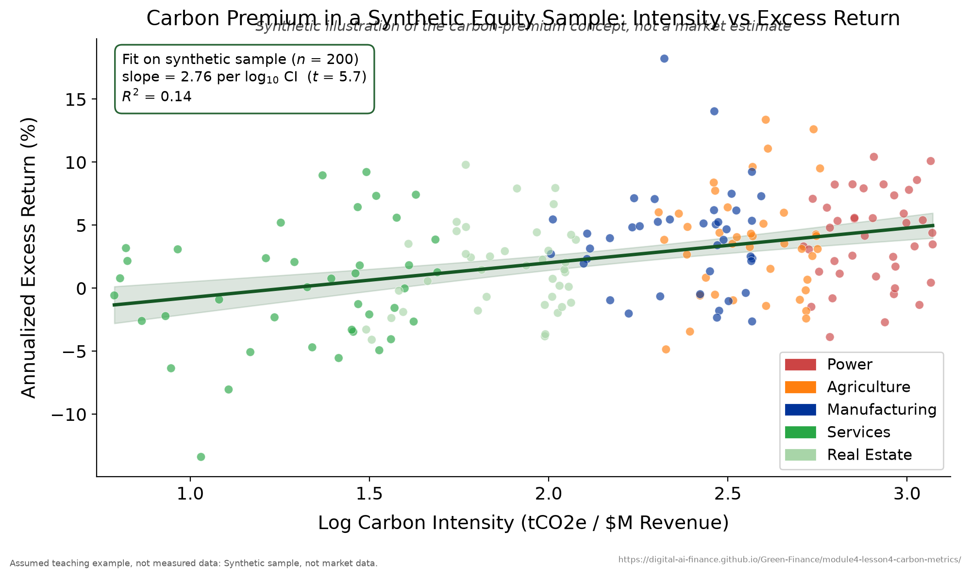
Carbon beta: evidence on whether the market prices carbon risk.
Whether markets already price transition risk is captured by the carbon beta in a factor model,
$$R_{i}=α+β_{mkt}R_{m}+β_{carbon} CarbonIntensity_{i}+ε_{i}.$$
A positive $β_{carbon}$ means investors demand a carbon premium, a higher return for holding carbon-intensive assets. Bolton and Kacperczyk (2021, Journal of Financial Economics) find such a premium in the US cross-section: a one-standard-deviation increase in the level of Scope 1 emissions is associated with about 1.8 percent higher annualized returns, and in the change of emissions with about 3.1 percent^{[5]}. Their post-Paris comparison is a caution rather than a result: the premium does look larger after 2015, but the rise is mostly due to new firms entering the sample, and excluding those new firms leaves it insignificant^{[5]}. The same authors later extend the result to a cross-section of over 14,400 firms in 77 countries, published in 2023^{[6]}. Replication on synthetic ASEAN data finds a weaker but present premium, concentrated in power and manufacturing, implying that carbon-intensive ASEAN firms may face a rising cost of capital.
Case study: the Vietnam agriculture-coal CVaR inversion. Illustrative worked example. A representative Vietnamese bank with $30 billion in assets has about 18 percent of its book in agriculture ($5.4B) and only 3 percent in coal and power ($0.9B). Financed-emissions accounting already surprises: coal is 3 percent of loans but 17 percent of the carbon footprint, while agriculture is 18 percent of loans and 38 percent of the footprint. The CVaR result inverts intuition entirely. Agriculture’s physical CVaR is about $281M ($\$5.4\text{B}×8\%×65\%$), whereas coal’s transition CVaR is only about $74M ($\$0.9\text{B}×15\%×55\%$). Three drivers explain the inversion: agriculture is much the larger book, Mekong Delta farming is acutely exposed to flooding that a warming climate makes more frequent, and agricultural output is far more thinly insured than power infrastructure, so uninsured losses flow straight into bank LGD instead of being absorbed by an insurer. The central lesson is that exposure size and physical vulnerability can dominate carbon intensity in determining financial risk.
Key concept: The headline result. The highest-emission sector is not always the highest-risk sector. Coal has the highest carbon intensity, but agriculture carries the larger Climate VaR because exposure is bigger, physical vulnerability is higher, and insurance is thinner. Carbon metrics do not just count emissions; they reveal where financial risk actually concentrates.
Teaching note. Build the chapter as the deck does, from “how much carbon?” to “where is the risk?”, and hold the inversion back as the payoff. The most common misconception is that the dirtiest sector is automatically the riskiest; the Vietnam case is the cure, so leave time for it. The PCAF, WACI, and CVaR formulas are all one-line calculations, so run them live and have participants reproduce the two CVaR worked examples. This is the natural home for the quantitative lab: the carbon dashboard shown in this chapter is computed for a synthetic 50-borrower portfolio, which participants can rebuild in Python as the lab exercise. Be explicit about data quality: most ASEAN figures are PCAF Tier 4 to 5, so always quote the uncertainty band. Budget about 55 minutes: 20 on metrics, 20 on CVaR, 15 on the inversion case.

Key takeaways
- Almost all of a bank’s emissions are financed emissions, on CDP’s evidence more than 700 times its direct emissions^{[8]}; PCAF attributes them by the outstanding-over-EVIC factor.
- WACI normalizes carbon intensity for portfolio comparison; coal-heavy generation pushes ASEAN portfolios above global and Paris-aligned benchmarks, but the benchmark to compare against is the reporting institution’s own, not a worked example’s.
- Most ASEAN carbon data sits in PCAF’s proxy tiers, so report the tier and the uncertainty range explicitly rather than a bare figure.
- CVaR decomposes into physical and transition channels; the dominant channel depends on the scenario.
- Exposure size and physical vulnerability can outweigh carbon intensity, as the agriculture-coal inversion shows.

Climate Stress Testing
Passing this year’s stress test says nothing about the next three decades.
Banks routinely pass supervisory stress tests built on three to five year horizons, but climate risk unfolds over three decades, intensifies non-linearly, and has no historical precedent. The real question is not whether an institution survives the next recession but whether it survives the next three decades. This chapter takes the Climate VaR of Chapter 4 and applies it to the whole balance sheet, asking the supervisory question directly: can the bank absorb climate losses and still meet its capital requirements?

Learning objectives
After this chapter you will be able to:
- Explain how a climate stress test differs from a traditional one.
- Describe the five design elements of a climate stress test.
- Convert scenario variables into PD and LGD shocks and compute post-stress capital.
- Contrast top-down and bottom-up, and static and dynamic, approaches.
- Interpret the BOT, ECB, and BoE exercises and the ASEAN capacity gaps.

What a climate stress test is
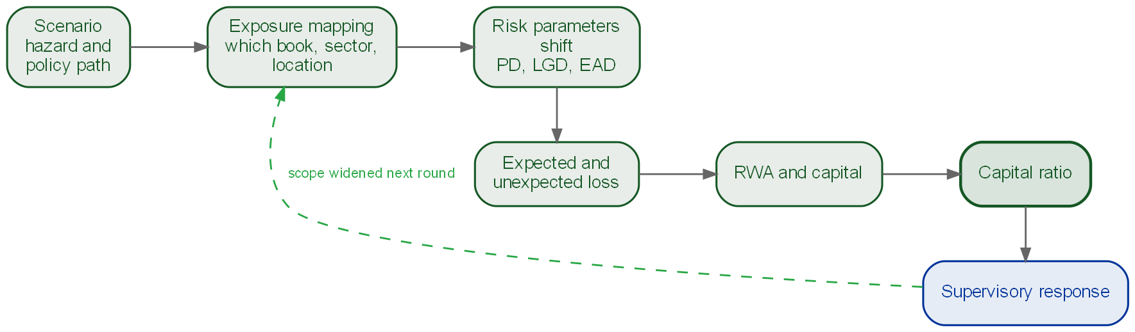
The five design elements as a pipeline, with the sixth thing that always happens: the supervisor reads the result and widens the scope next round.
A climate stress test assesses whether an institution can absorb climate-related losses while maintaining regulatory capital under plausible but severe scenarios. It differs from a traditional exercise on every axis: the horizon is multi-decadal rather than a few years, the uncertainty is deep rather than parametric, the data is novel and proxy-based rather than historical, and the scope is economy-wide rather than single-institution. Every climate stress test is built from five design elements in sequence: scenario selection (NGFS pathways or bespoke physical events), transmission channels (how scenarios become PD, LGD, and market shocks), portfolio mapping (assigning exposures to affected sectors and geographies), loss estimation (expected loss under stressed parameters), and capital impact (whether the post-stress capital ratio clears the regulatory minimum).

The supervisory landscape
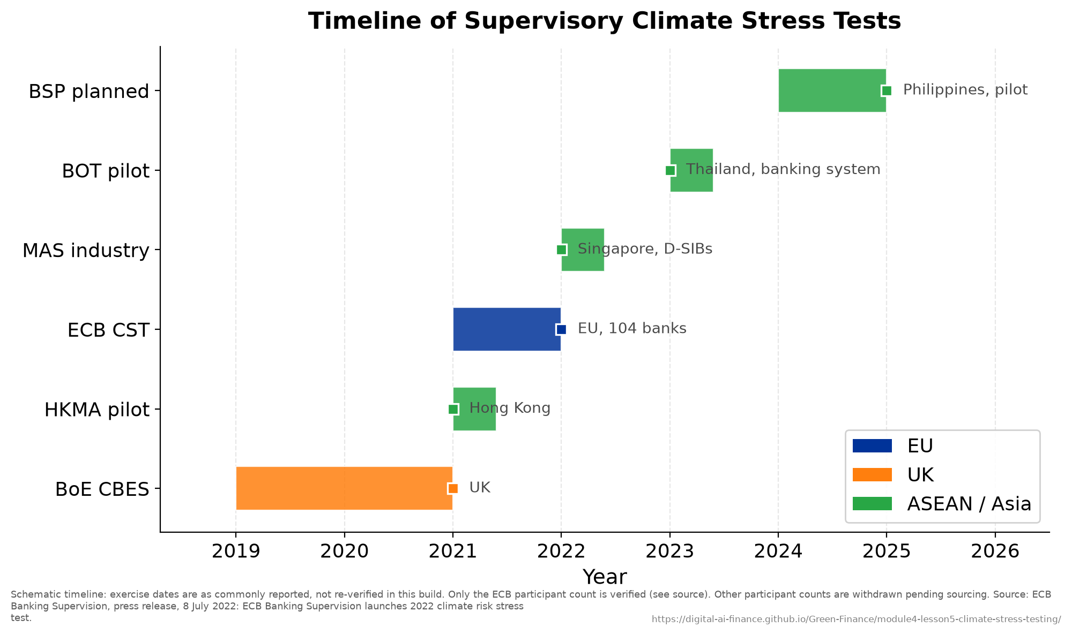
Timeline of supervisory climate stress tests.
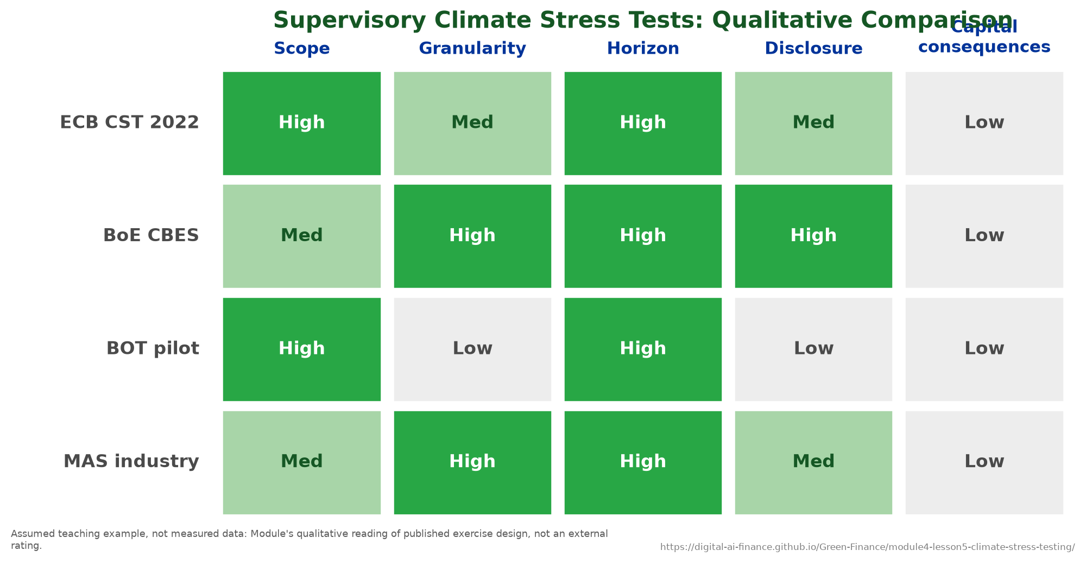
Comparison of supervisory stress-test designs.
Climate stress testing has moved from a supervisory experiment to standard practice across the major jurisdictions. The ECB’s 2022 exercise was the largest of its kind, with 104 significant banks participating^{[13]}; the Bank of England’s 2021 CBES was a counterparty-level exercise over the largest UK banks and insurers that held balance sheets fixed at end-2020; the HKMA (2021), MAS (2022), and BOT (2023) led in Asia. ASEAN supervisors are catching up quickly, with the BOT and MAS in front.
The output of any such exercise is a single number, the post-stress capital adequacy ratio (CAR), judged against the Basel III floor: a minimum total capital ratio of 8.0 percent plus a capital conservation buffer of 2.5 percent, that is 10.5 percent^{[1]}. A bank that breaches must restrict dividends, raise capital, or cut exposures; the value of the test is that it forces that conversation before the crisis rather than during it.

Transmission, loss, and capital
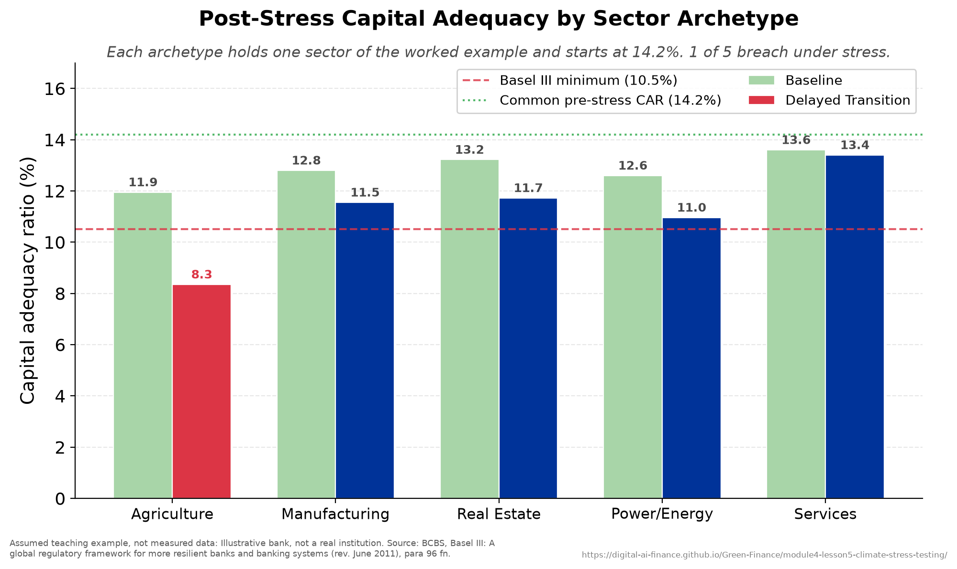
Capital adequacy ratio, before and after the stress.
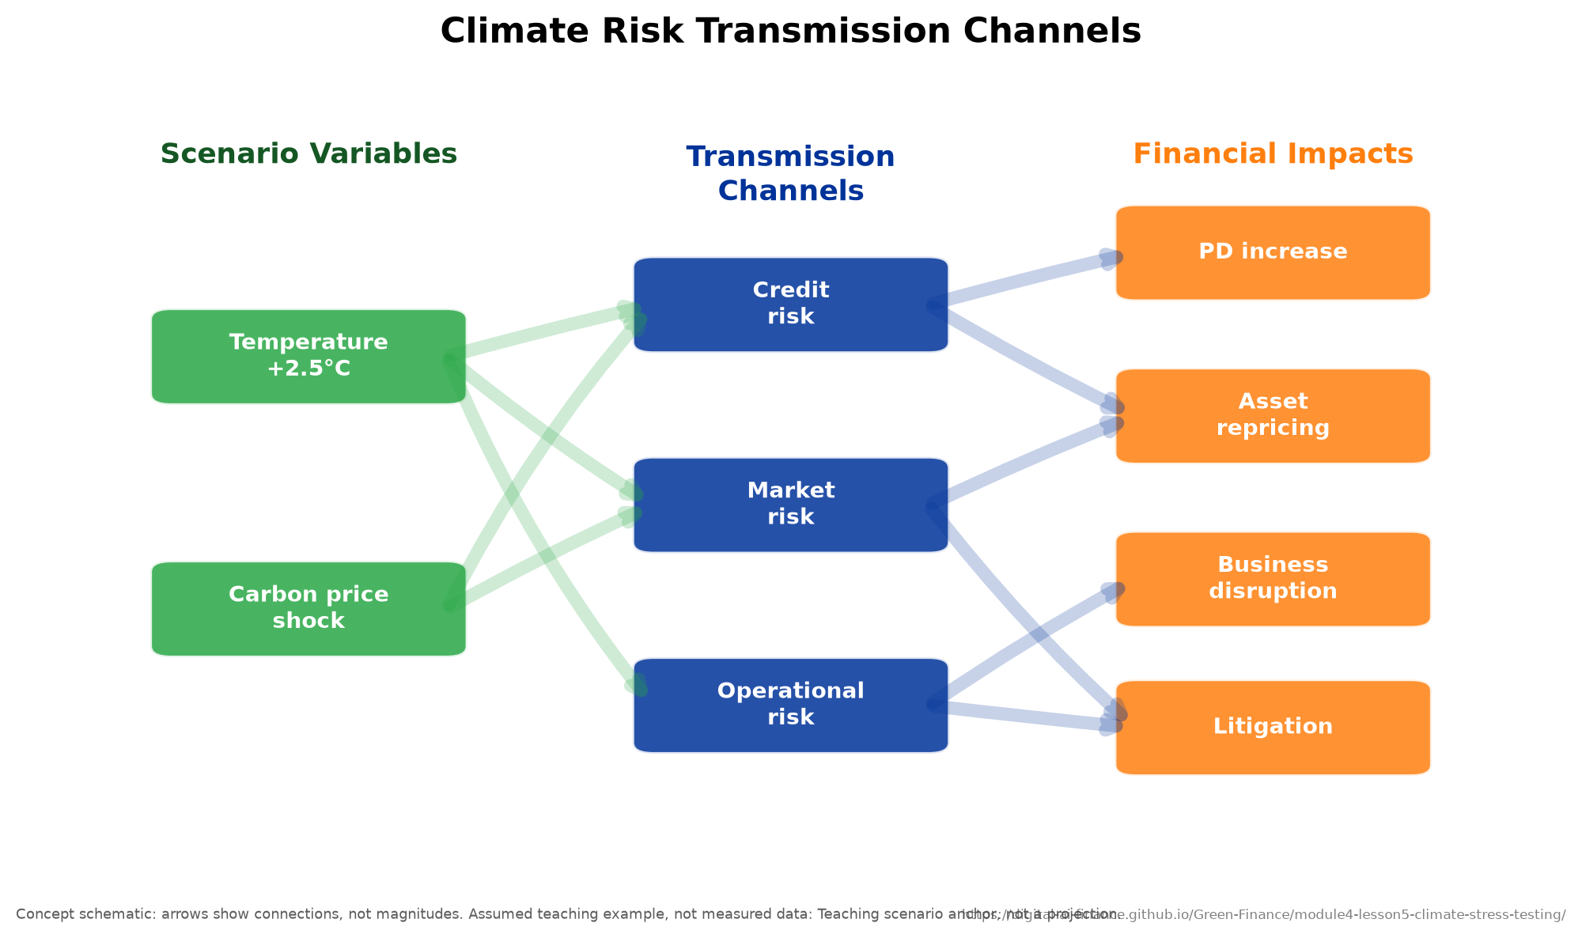
Stress transmission channels from scenario to capital.
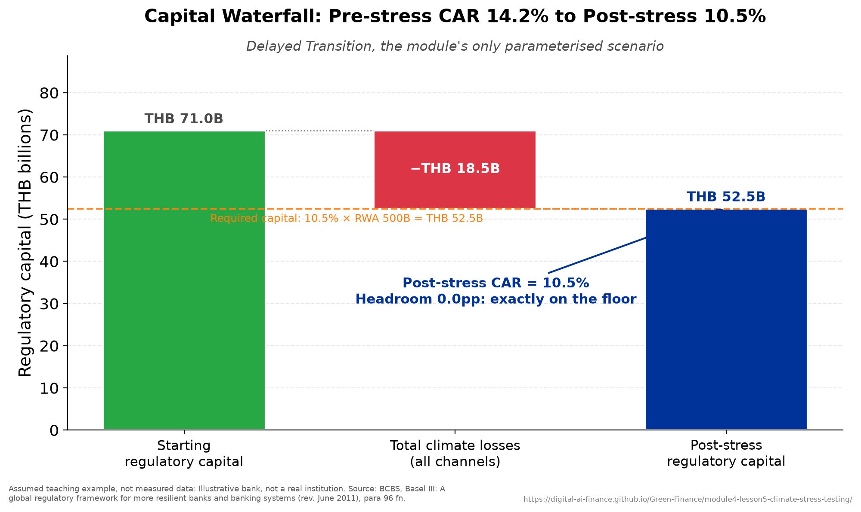
The capital-loss waterfall under stress.
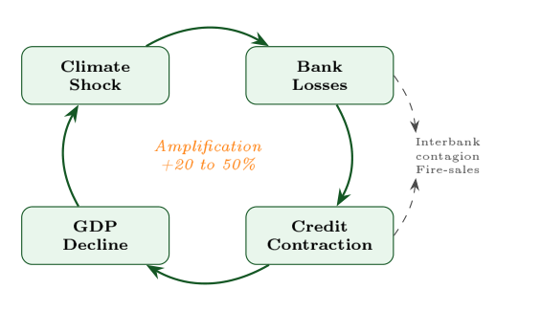
Why the first round is not the whole loss: losses cut capital, tighter capital cuts credit supply, weaker borrowers default more, and the cycle returns to where it began.
Scenario variables enter the credit model as multipliers. A simple specification scales the baseline default rate, $PD_{climate}=PD_{base} (1+\text{stress multiplier})$, so Thai agriculture with a 5 percent baseline and a flood-driven multiplier of 0.80 reaches 9.0 percent; loss given default adds a physical-damage uplift, $LGD_{climate}=LGD_{base}+Δ_{physical}$, taking 45 percent to 65 percent. Expected loss is then $EL=PD×LGD×EAD$ summed across sectors. For a five-sector Thai bank with THB 500 billion of exposure under a delayed-transition scenario, climate stress roughly doubles expected loss from about THB 6.5 billion to THB 14.1 billion, with agriculture contributing 42 percent of the increment despite being only 20 percent of exposure.
The capital question follows directly:
$$CAR_{post}=\frac{RegCapital-ClimateLosses}{RWA}.$$
A bank with THB 71 billion of capital and THB 500 billion of risk-weighted assets has a pre-stress CAR of 14.2 percent; THB 18.5 billion of climate losses pull it to exactly 10.5 percent, leaving zero headroom and triggering capital action.

Design choices that move the answer
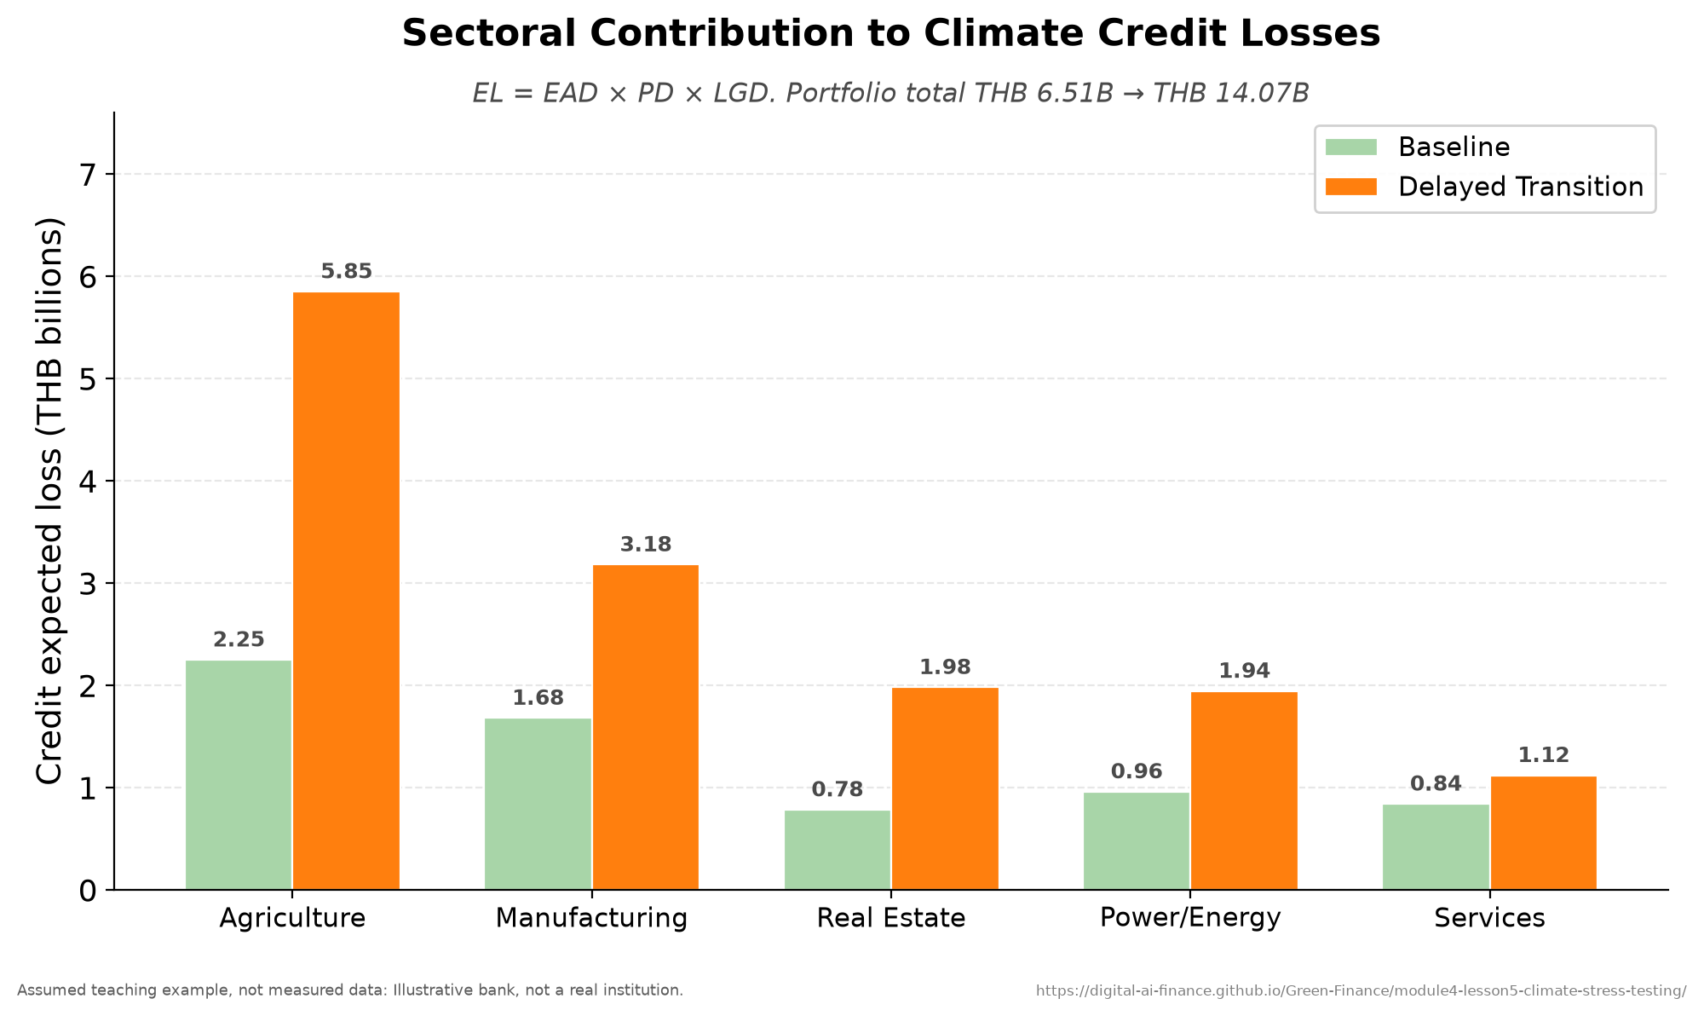
Sectoral contributions to stressed losses.
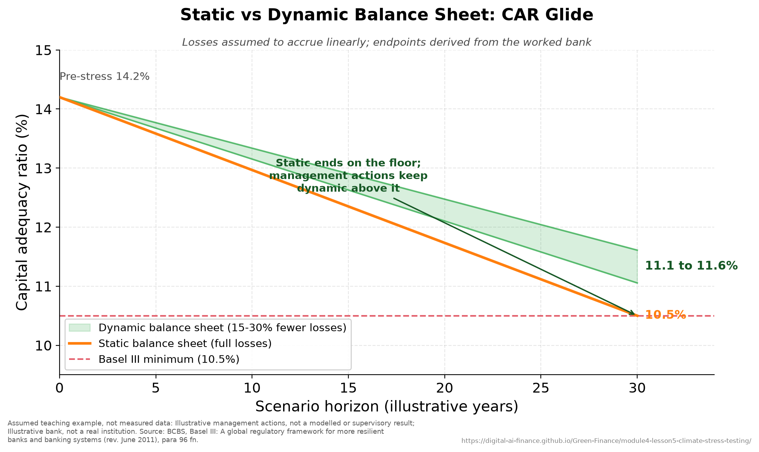
Static versus dynamic balance-sheet capital paths.
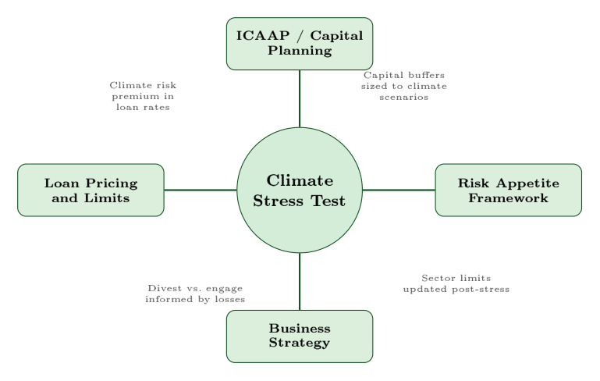
Where the result of a stress test lands in the enterprise risk framework.
Three modelling choices materially change results. Top-down exercises apply uniform supervisory shocks for cross-bank comparability (ECB, HKMA, BOT), while bottom-up exercises let banks use their own loan-level models for accuracy (BoE, MAS); best practice uses both. Static balance sheets freeze the portfolio for comparability, as both the ECB exercise and the BoE CBES did for their core loss projections; a fully dynamic balance sheet that let banks rebalance would cut modelled losses materially, but supervisors have largely kept balance sheets fixed (the BoE collected firms’ management actions only qualitatively). Finally, most exercises model only first-round losses and omit second-round effects, yet Battiston et al. (2017) show that propagation through direct and indirect exposures can turn a late and abrupt policy shift into an adverse systemic event, so headline supervisory numbers understate. The ECB put combined credit and market risk losses at around EUR 70 billion for the 41 banks that provided projections^{[12]} and wrote in the same report that “for a number of reasons this estimate significantly understates the actual risk”^{[12]}.
Key concept: PhD extension: why stress tests understate the tail. Acharya et al. (2023) give four reasons current exercises understate risk: they use median pathways rather than 99th-percentile tails, they ignore tipping-point non-linearities, they omit network contagion, and they cannot be back-tested because the stress has never occurred. Their proposed fixes are agent-based models of heterogeneous bank behaviour, Extreme Value Theory for the tails, multi-model ensembles, and reverse stress tests that ask what scenario would break the bank. The practical takeaway for a supervisor is to treat results as directional lower bounds, not point estimates, and to integrate the test into capital planning, risk appetite, and loan pricing rather than running it as a compliance exercise.
Case study: the Thailand 2011 floods and the BOT 2050 projection. The 2011 Thailand floods caused about $46.5 billion^{[25]} in damage and losses, on the scale of a major sovereign shock rather than an insurable incident. Insurance covered only a fraction of it, industrial estates across the central provinces stood under water for weeks, and national output fell for the rest of the year. Notably, Thailand’s system-wide non-performing-loan ratio did not spike: it fell over the following year as the BOT and banks deployed large-scale debtor relief and forbearance, which masked the underlying credit stress. That is a caution against reading headline NPLs as the full impact, and a reminder that policy response is itself part of the transmission channel. The BOT uses the event as the physical anchor for its 2023 climate stress test. The illustrative calibration: treat the flood as a roughly 10 to 20 year event, and assume that under a hot-house 2050 pathway such events become about 2.5 times more frequent with a 1.3 times severity uplift, so an assumed 0.9 percentage-point sector NPL shock scales to $0.9×2.5×1.3≈2.9$ percentage points. For a representative THB 600 billion bank, hot-house losses reach about THB 28 billion and pull CAR from 16.2 percent to 12.8 percent, leaving a little over two points of headroom, a worse outcome than the Net Zero result, with agriculture alone accounting for more than half the losses. This is the exact inverse of European exercises, where transition risk dominates.

The ASEAN capacity-building agenda
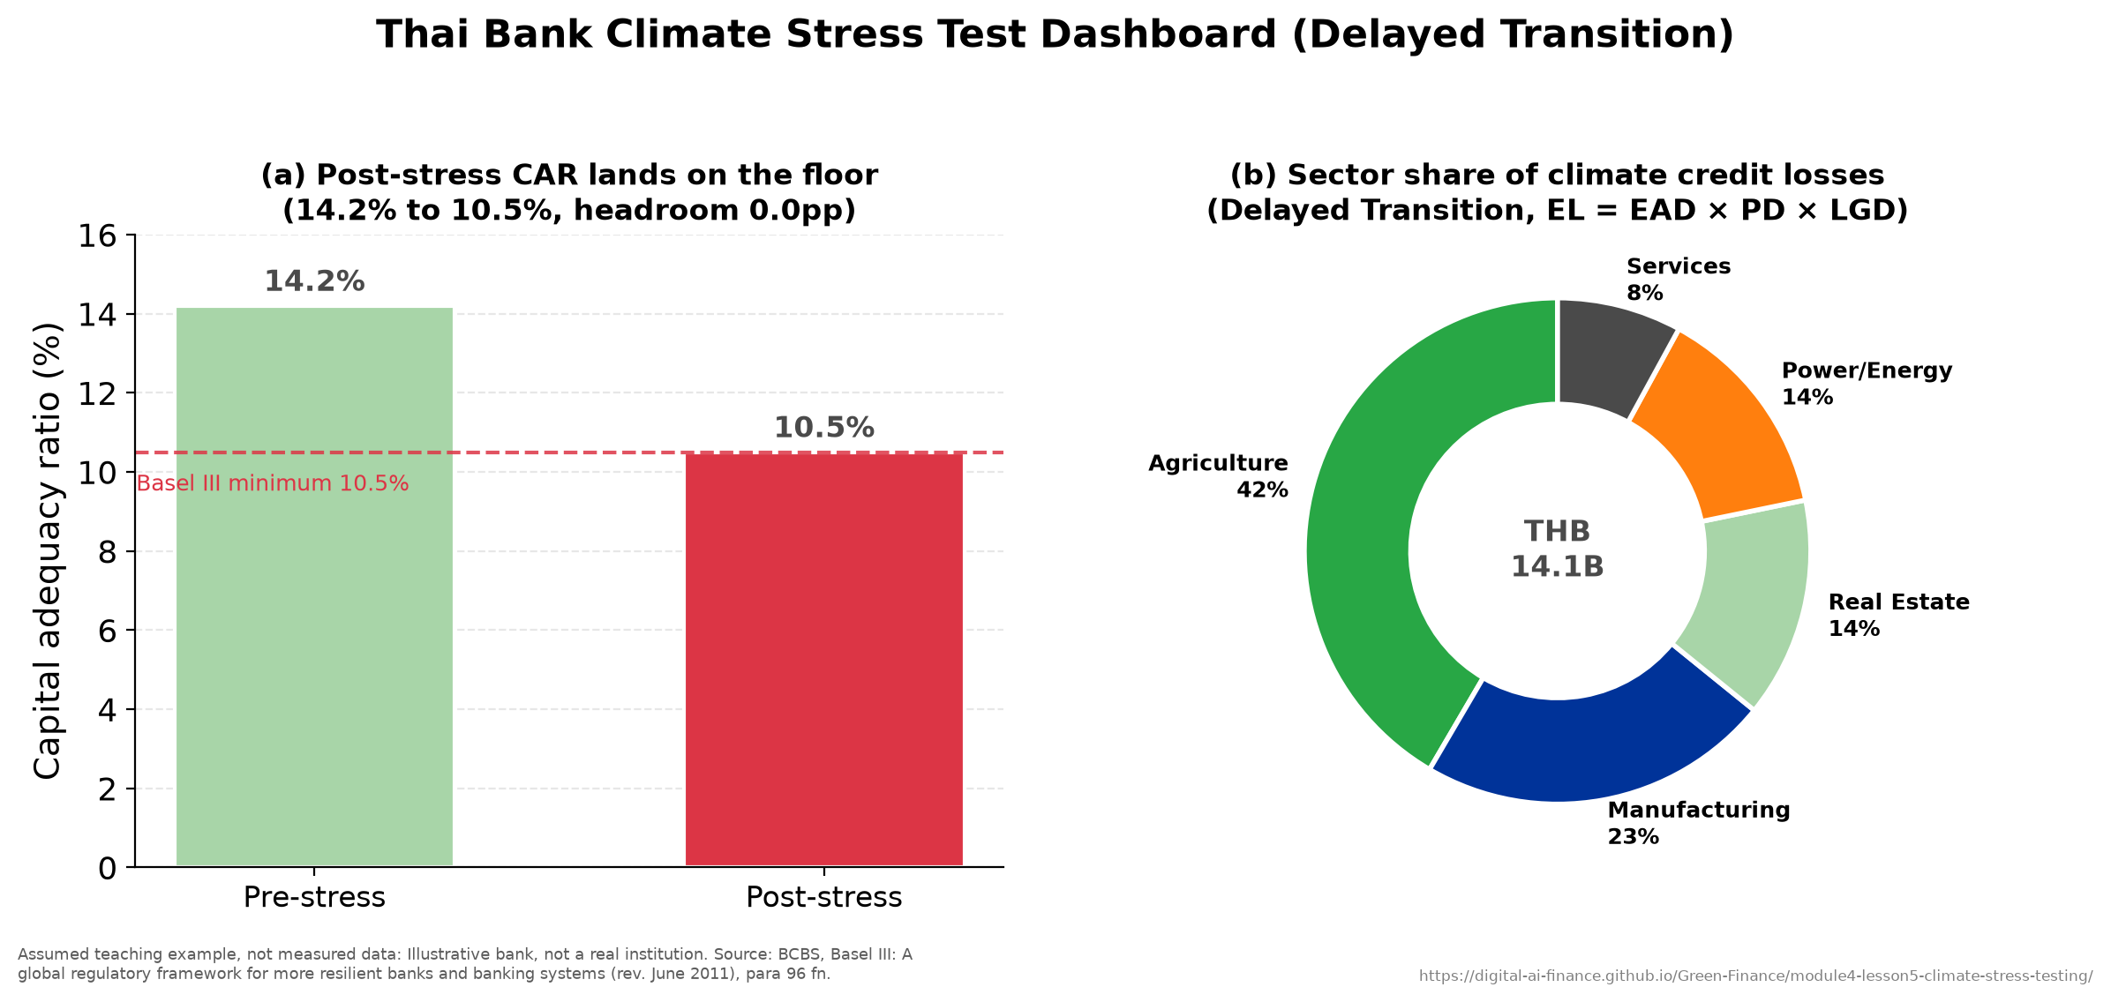
Thailand 2011 floods: a stress-test dashboard.
The BOT exercise is a strong first step that is comparable in maturity to ECB 2022, and the gaps it shares with its peers define a regional roadmap. Five gaps recur across ASEAN: thin data infrastructure (build borrower-level emissions registries linked to loan books); unharmonized methodology (different proxies give materially different PD shocks for the same portfolio, so an ASEAN-wide protocol is needed); physical-risk models not yet wired into bank systems (GIS-linked platforms); static-only balance sheets (phase in dynamic modules); and the omission of second-round effects (agent-based network models). Each gap maps to a concrete WP3 capacity-building deliverable, which is why this material sits at the centre of the project.
Teaching note. The spine of the lesson is the five design elements and the single output, post-stress CAR; teach those first and everything else hangs off them. The most effective demonstration is to walk the Thai five-sector expected-loss table and the CAR calculation live, then show how the 2011 floods calibrate the forward projection, since the 2.5-times frequency scaling makes the abstraction concrete. Reinforce the recurring Module 4 theme that in ASEAN physical risk dominates transition risk, the inverse of Europe. The static-versus-dynamic and second-round material is the natural PhD-level extension to assign as reading if time is short. Budget about 55 minutes: 15 on design and the supervisory landscape, 20 on transmission and capital, 20 on the Thai case and the capacity agenda.

Key takeaways
- Climate stress tests look forward over decades under deep uncertainty; the five design elements run from scenario to capital impact.
- Post-stress CAR is the headline output, judged against the Basel III minimum-plus-buffer floor.
- Static balance sheets and the omission of second-round effects mean published losses are lower bounds.
- For agriculture-heavy ASEAN economies physical risk dominates transition risk; the BOT projection shows agriculture driving over half of hot-house losses.

ASEAN Climate Vulnerability
Every tool in this module, pointed at one region.
This is the Module 4 capstone, where every tool from Chapters 1 to 5 converges on one region. Southeast Asia faces rising seas, intensifying typhoons, prolonged droughts, and coral bleaching at the same time, across a region of hundreds of millions of people, and physical risk dominates while transition risk catches up. The organizing identity is simple,
$$\text{Risk}=\text{Hazard}×\text{Exposure}×\text{Vulnerability},$$
and ASEAN scores high on all three terms, which is why climate risk translates so directly into financial loss here.

Learning objectives
After this chapter you will be able to:
- Apply the hazard-exposure-vulnerability framework to Vietnam, Thailand, and the Philippines.
- Decompose the ND-GAIN index into vulnerability and readiness.
- Explain the ASEAN adaptation finance gap, why its size is contested, and which instruments address it.
- Outline the empirical methods used to study climate and finance in the region.
- Run an integrated country stress test and read its capital implications.

Why ASEAN is the climate risk hotspot
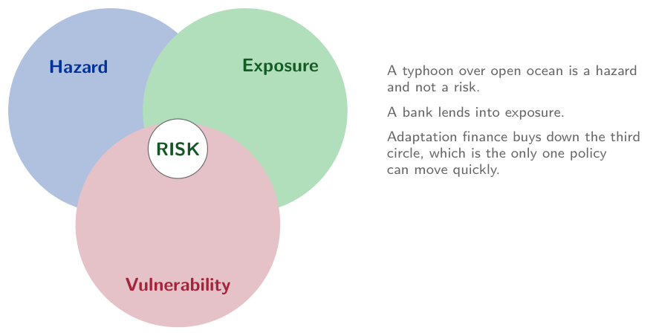
Risk is the intersection, not any one circle. A typhoon over open ocean is a hazard and not a risk; adaptation buys down vulnerability, the only term policy can move quickly.
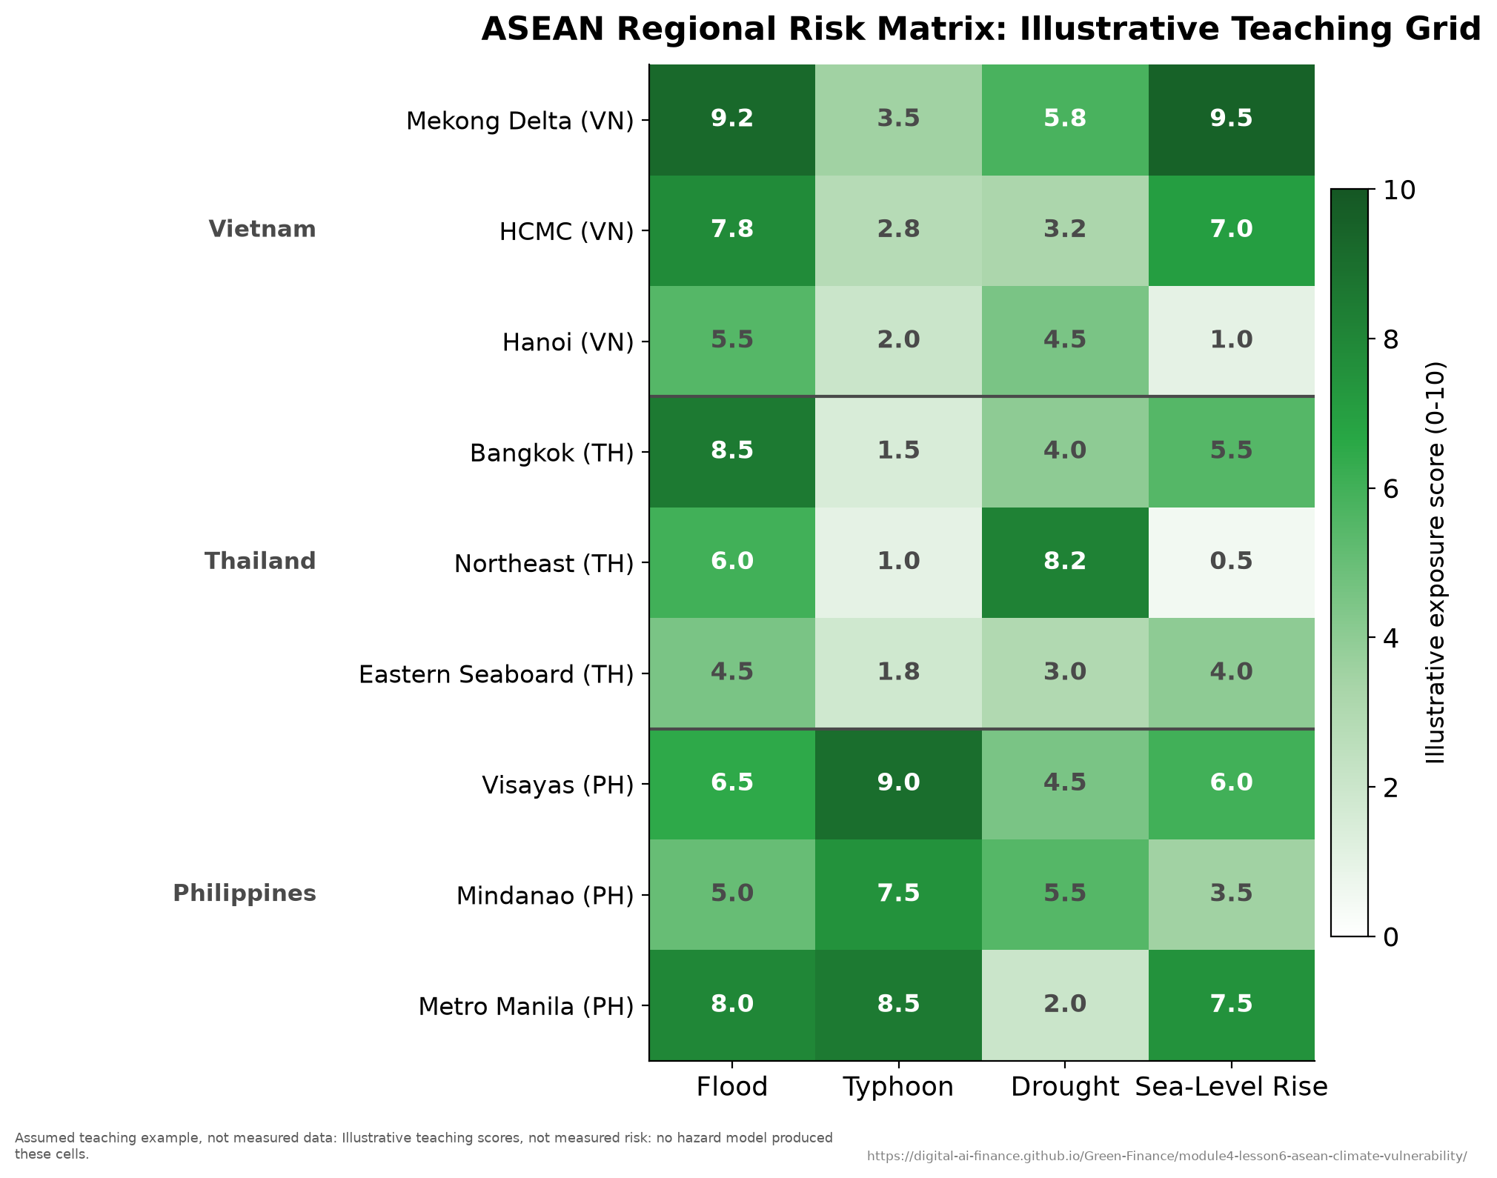
Spatial distribution of ASEAN climate risk.
The three terms of the risk identity reinforce each other in Southeast Asia, and the reinforcement is the point: a region can score badly on one term and still manage, but ASEAN scores badly on all three at once. The hazard is tropical: typhoons, monsoon flooding, sea-level rise, and coral bleaching arrive together rather than in turn. The exposure is large: long coastlines, an agricultural sector that is a substantial share of output and employment, and much of the population living in coastal and delta zones. The vulnerability is high: middle incomes, thin insurance penetration, and limited early-warning infrastructure, so a shock that a wealthier and better-insured economy absorbs is one this region borrows against. That combination of high hazard, high exposure, and low adaptive capacity is what makes ASEAN the place where climate risk most directly becomes a credit, market, and operational loss.

Three country profiles
Each of the three focus countries carries a distinct risk signature, and the differences matter more than the similarities, because they imply different supervisory priorities. Vietnam faces compound physical risk: Mekong Delta salinity driven by sea-level rise and saltwater intrusion, Ho Chi Minh City subsidence, and Red River flooding converge on the same loan books, with Agribank concentrated in exactly the rural lending those hazards hit. Thailand spans urban subsidence and flood (the 2011 floods cost about $46.5 billion^{[25]}), northeastern drought affecting the agricultural bank BAAC, and projected coral loss threatening coastal tourism revenue. The Philippines is the most disaster-prone, with about 20 tropical cyclones forming in the region each year and 8 or 9 crossing the country^{[21]}, and it also has the most advanced regulatory response, the BSP disclosure mandate of 2022. Note the pattern: the country with the highest hazard has moved fastest on supervision, which is the empirical regularity Chapter 2 identified across ASEAN.
Three ASEAN countries compared. The comparison is deliberately ordinal: the teaching point is the ranking and the divergence between vulnerability and readiness, which is stable, rather than decimal precision on figures that move with every data vintage.
Dimension | Vietnam | Thailand | Philippines
Primary hazard | Sea-level rise, delta flooding | Subsidence-flood, drought | Typhoons, recurrent
Annual losses | Moderate and rising | Episodic but severe | Highest of the three
Insurance penetration | Thin | Deepest of the three | Thin
ND-GAIN standing | Vulnerable, low readiness | Least vulnerable, highest readiness | Vulnerable, low readiness
Regulatory stage | SBV guidelines 2024 | BOT stress test 2024 | BSP mandate 2022
The ND-GAIN index (from the Notre Dame Global Adaptation Initiative) separates vulnerability (exposure, sensitivity, and adaptive capacity across life-supporting sectors) from readiness (economic, governance, and social capacity to act). Vietnam and the Philippines score similarly on vulnerability but diverge on readiness, with Thailand ahead on governance and economic readiness; that vulnerability-readiness gap is what defines each country’s adaptation priorities.

The adaptation finance gap
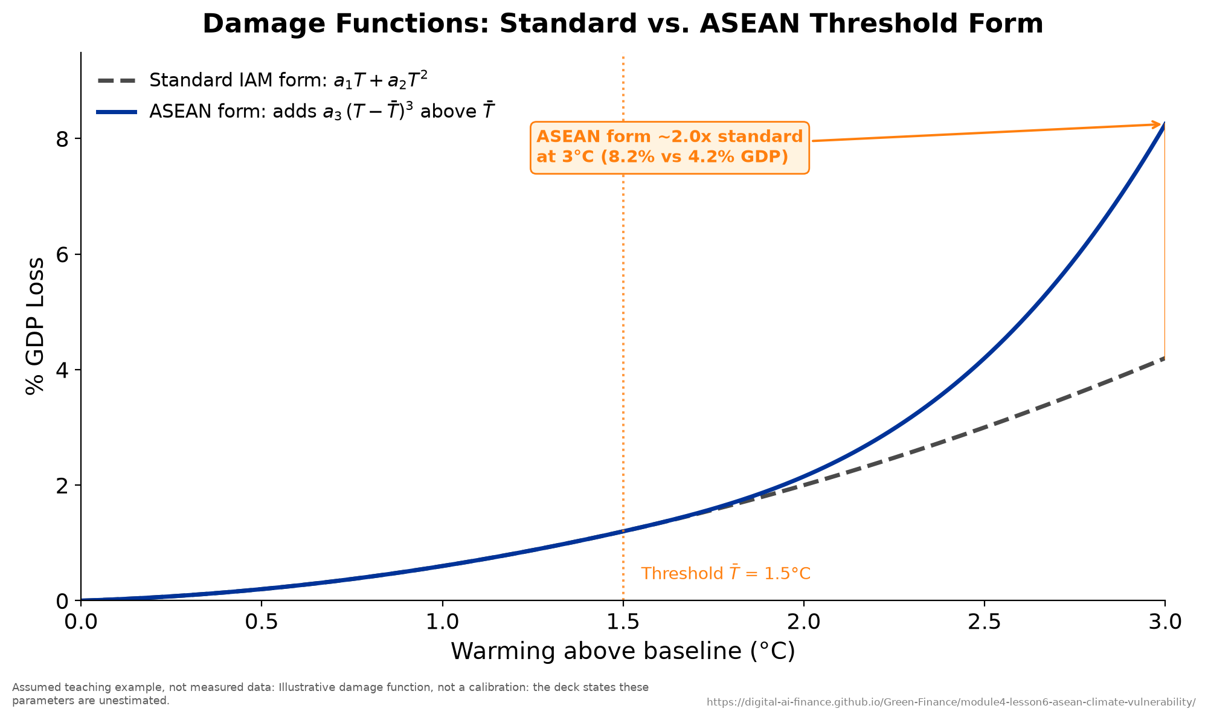
Climate damage functions.
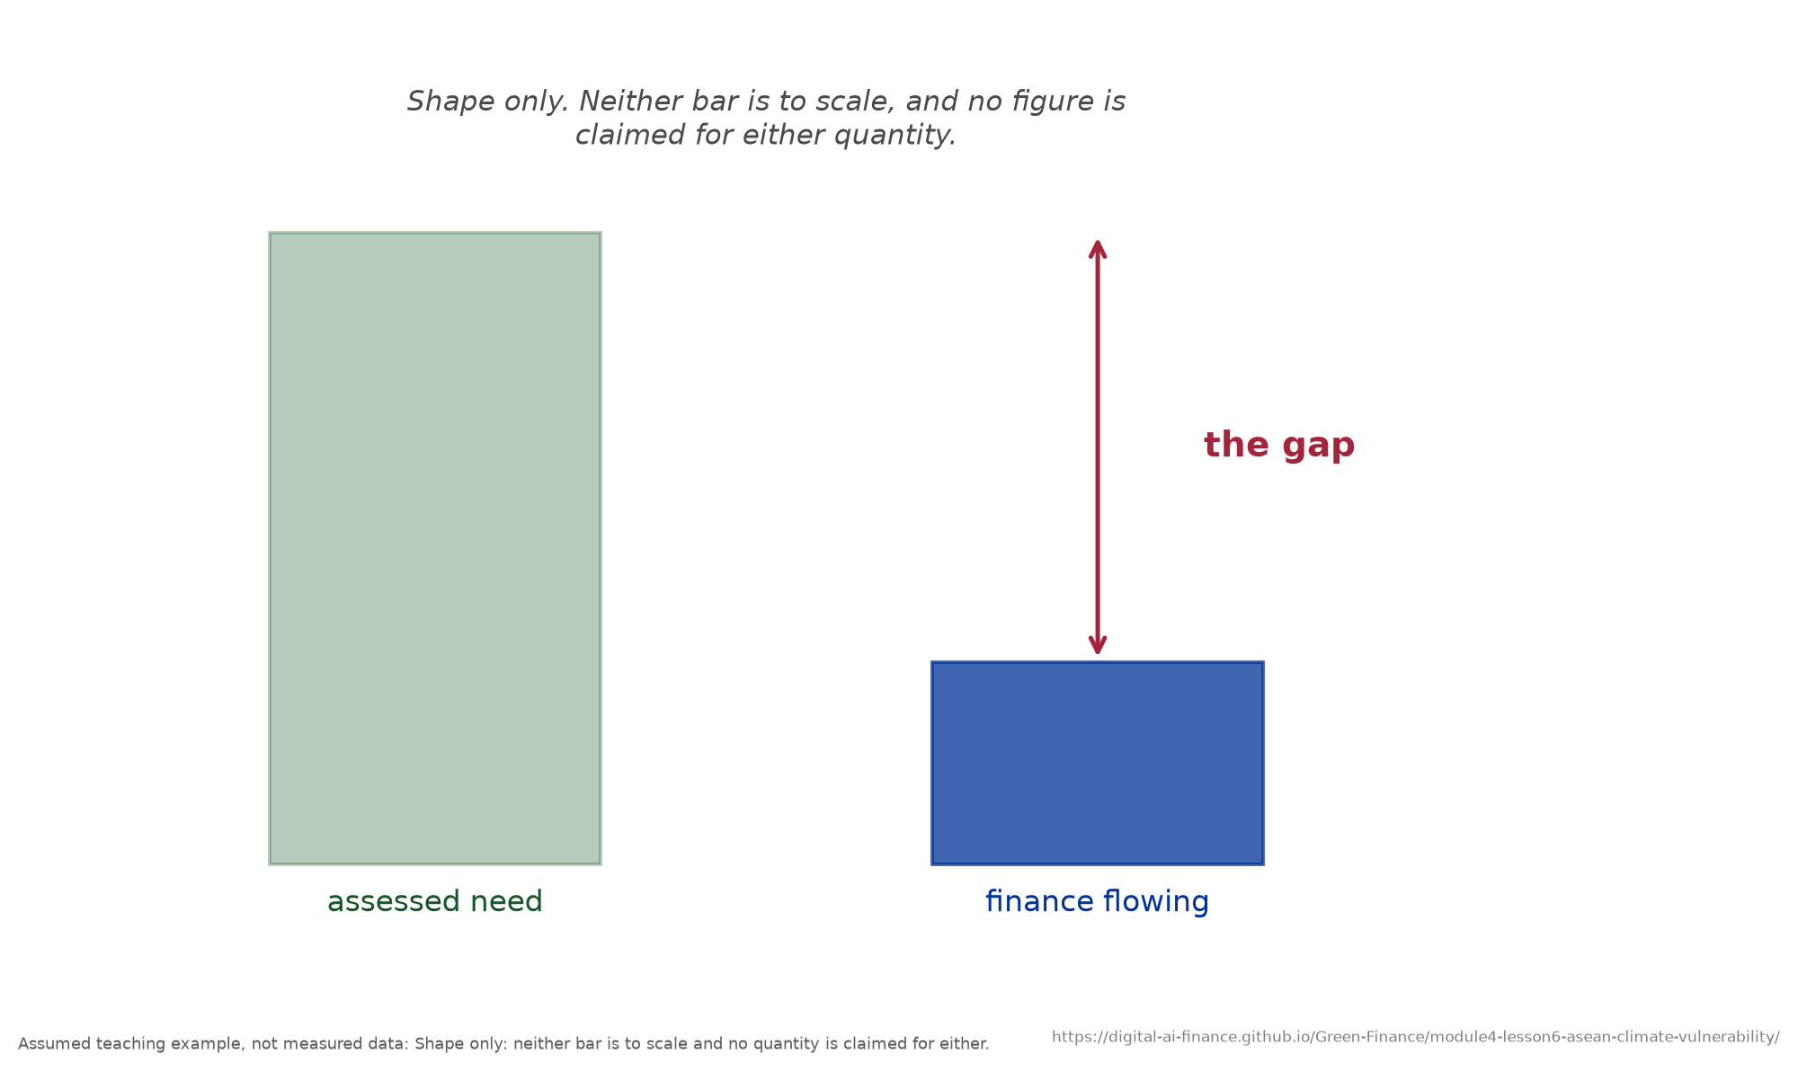
The relationship the cited figures describe, drawn without asserting its size.
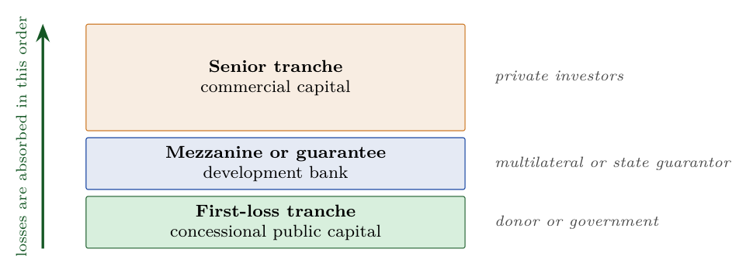
The blended-finance capital stack: the order in which losses strike the tranches is the whole mechanism.
Mitigation alone cannot protect ASEAN, because substantial warming and sea-level rise are already locked in, so adaptation is a survival imperative rather than an option. Yet global climate finance is badly skewed: average annual flows reached almost $1.3 trillion in 2021/2022^{[10]}, of which adaptation drew $63 billion, a small fraction of the total, against estimated needs of $212 billion a year by 2030 for developing countries alone^{[10]}. The regional picture is worse than that global one, because ASEAN bears a share of physical-risk losses far out of proportion to its share of cumulative emissions: it is paying for a stock of emissions it did not create.
A caution belongs here, and it is part of what this chapter teaches rather than a footnote to it. Widely quoted ASEAN adaptation-gap figures are not reproducible from primary sources. Published estimates differ by close to an order of magnitude depending on whether they cover Asia or Southeast Asia, adaptation alone or climate finance combined, an annual gap or a total need, and which baseline year is used. A widely repeated need-versus-mobilized pairing was carried here in earlier drafts and has been withdrawn, along with the chart that plotted it, because it could not be traced to a primary source at the scope it claimed: the need figure turns out to be an Asia-wide estimate quoted as an ASEAN one. That is the characteristic failure, and it is worth recognising, because a number loses its scope long before it loses its authority. Prefer the global figures above, which are sourced, and treat any single headline gap figure for the region as an estimate whose scope you must check before repeating it. That the number is so hard to pin down is itself the finding: adaptation finance is poorly tracked, and what is not measured does not get managed.
The instruments to close the gap fall into market-based tools (catastrophe bonds with parametric or indemnity triggers, such as the Philippine sovereign parametric typhoon bonds and the regional SEADRIF facility; resilience bonds; and parametric insurance) and public or multilateral capital (the Green Climate Fund, whose mandate is to balance mitigation and adaptation, and the Adaptation Fund). Parametric instruments deserve particular attention here, because they pay on a measured trigger such as wind speed rather than on an assessed loss, which means the money arrives in days rather than after a claims process, and speed is most of the value when the loss is a destroyed harvest. The mechanism that links the two families is blended finance, which stacks a thin layer of concessional first-loss capital, a guarantee or mezzanine layer, and a majority senior commercial tranche, so that public money absorbs the first losses and private capital will price the rest. The metric to watch is how much private capital each public dollar mobilizes; across ASEAN it runs well below what the instruments are designed to achieve. Conditionality is the binding constraint on national pledges: several ASEAN nationally determined contributions make the larger part of their target conditional on international finance, so without closing the gap those targets remain aspirational. Throughout, the just-transition principle requires that adaptation reach coastal communities, smallholder farmers, and informal workers, not only large corporates.
Key concept: PhD extension: how the region is studied. The empirical toolkit is standard applied econometrics adapted to climate data. Panel fixed-effects models, $NPL_{it}=α+β_{1}ClimateEvent_{it}+…+γ_{i}+δ_{t}+ε_{it}$, isolate the within-country effect of disasters on bank asset quality (Cevik and Jalles, 2022, find that disaster events raise non-performing loans measurably, with the effect moderated by insurance penetration, which is the empirical counterpart of the protection-gap argument made throughout this module). Difference-in-differences evaluates disclosure mandates such as the BSP’s 2022 rule, instrumental-variable designs address the endogeneity of where adaptation finance is allocated, GIS spatial models overlay fine-grained hazard grids onto geocoded loan books, and ASEAN-calibrated damage functions add a threshold term, $D(T)=a_{1}T+a_{2}T^{2}+a_{3}1(T>\overset{‾}{T})(T-\overset{‾}{T})^{3}$, to capture tropical tipping points that global functions miss. Cross-border spatial panels capture the contagion seen when the 2011 Thai floods disrupted regional supply chains.
Case study: a Cat-5 typhoon stress test for the Philippines. Illustrative worked example. The Philippine banking system is concentrated in a modest number of universal and commercial banks with a wide branch network across the typhoon-exposed Visayas and Mindanao, while the national crop insurance programme reaches only a minority of farmers. Applying the full Module 4 toolkit to a Haiyan-class Category 5 typhoon making landfall in Central Visayas, assumed sectoral default-probability shocks (agriculture plus 80 percent, real estate plus 40 percent, services and tourism plus 25 percent, each relative to that sector’s own baseline rather than in percentage points) give a portfolio-weighted relative increase of about 22.6 percent. Feeding that through the capital identity starts from a real number rather than an assumed one: the Philippine banking system’s actual solo capital adequacy ratio in December 2023, 16.6 percent^{[3]}. The assumed shocks take it to 13.5 percent, leaving 3.5 points above the BSP’s own minimum of 10 percent. Note that the Philippine floor is not the Basel III figure used in Chapter 5: national buffer rules differ, so a bank that clears one supervisor’s minimum may not clear another’s, and a cross-border comparison of post-stress ratios has to compare each against its own floor. The aggregate system survives, but a handful of smaller Visayas-concentrated banks breach the minimum: the systemic risk is concentrated, not average, and a supervisor reading only the system average would miss it entirely. The policy response follows directly, namely mandatory bank-level climate stress testing, portfolio-level parametric crop cover, and a blended-finance facility for resilient infrastructure, all viewed through a just-transition lens.

Five gaps and the bridge to Module 5
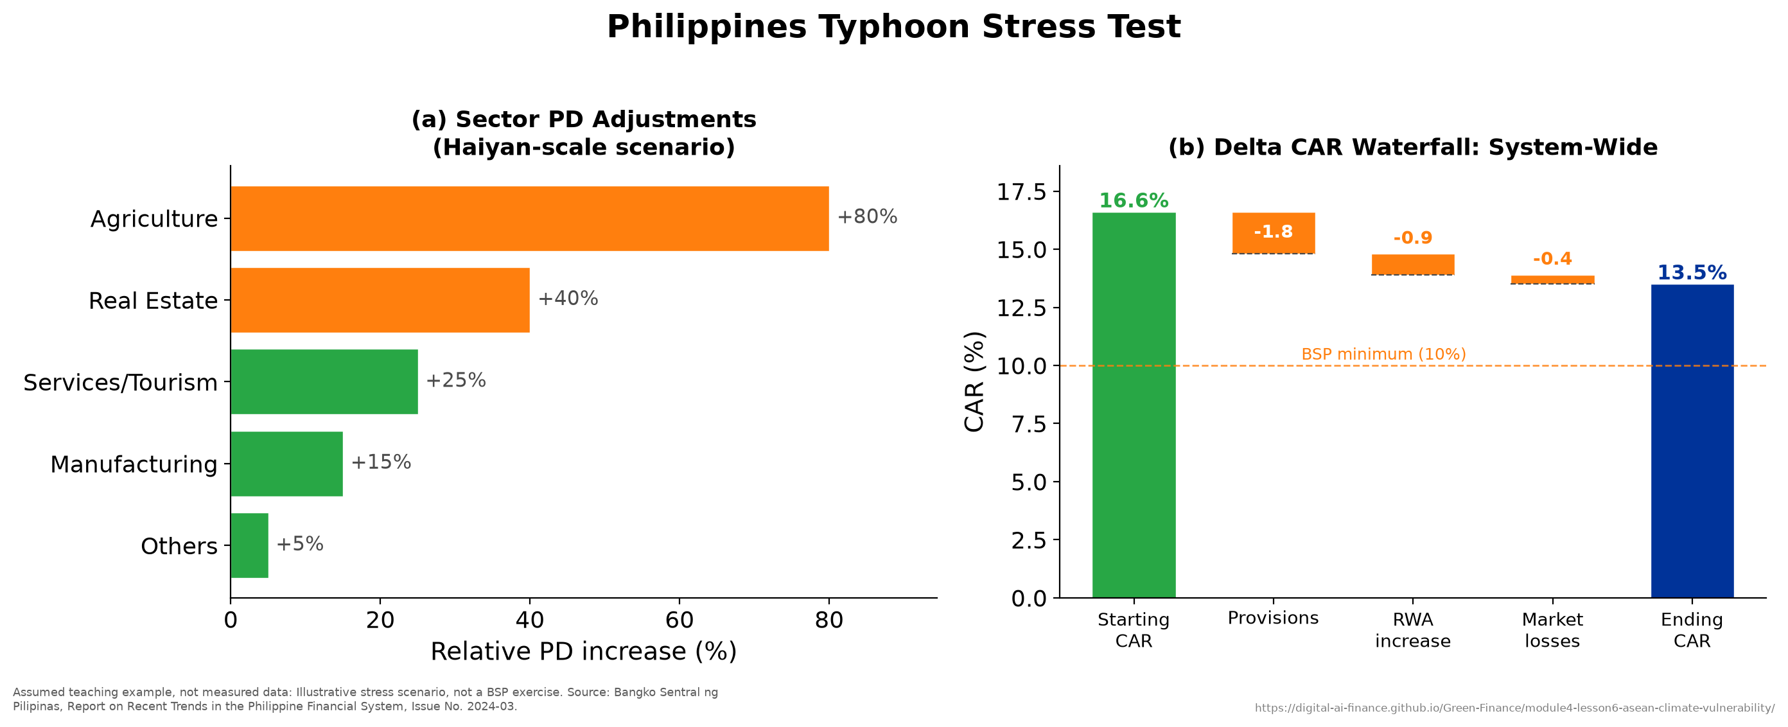
Philippines Category-5 typhoon stress-test dashboard.
Five gaps define the regional agenda and map onto this project’s work: a data gap (no geocoded hazard-to-loan-book database across ASEAN), a methodology gap (PD shocks for the same scenario vary widely across jurisdictions, so results are not comparable), the finance gap set out above, a capacity gap (ASEAN supervisors run their climate programmes with a small fraction of the specialist staff their European counterparts deploy, which is exactly what a capacity-building programme like this one addresses), and a coordination gap (no ASEAN-wide stress-test protocol despite cross-border transmission). Module 4 has taught you to identify, measure, and manage climate risk; Module 5 turns to reporting and communicating it through ISSB S1 and S2, CSRD, and SFDR. Risk management without reporting is invisible, and reporting without risk management is empty.
Teaching note. As the capstone, this chapter works best as integration rather than new content: open with the hazard-exposure-vulnerability identity, then show the same tools from Lessons 1 to 5 applied to three countries, and close on the Philippines stress test that chains taxonomy, scenario, metric, and capital into one worked example. Participants who will re-deliver the module can pair this chapter with the Thailand catastrophe tail-risk case in Appendix A, which applies the same tools end to end. The empirical-methods section is the natural PhD-level extension to assign as reading. Reinforce the recurring theme one last time: in ASEAN, physical risk dominates and adaptation finance is the binding constraint. Budget about 50 minutes: 15 on the regional profile, 15 on the finance gap, 20 on the Philippines capstone.

Key takeaways
- Risk equals hazard times exposure times vulnerability, and ASEAN scores high on all three.
- ND-GAIN separates vulnerability from readiness; the gap between them sets adaptation priorities.
- Adaptation is chronically underfunded against need, and the regional gap is tracked so poorly that its size is contested; blended finance and parametric instruments are the main mechanisms proposed to close it.
- The Philippines capstone shows aggregate resilience but concentrated regional breaches, so supervision must look beyond system averages.
- Module 4 manages climate risk; Module 5 reports it.

Practical Activity: ASEAN Case Study (Thailand Catastrophe Tail Risk)
This appendix is a self-contained teaching case that applies the Climate VaR ideas of Chapter 4 and the capital-adequacy logic of Chapter 5 to a concrete supervisory question. It is adapted from the project case library and is designed as a 45 to 60 minute session. The case is quantitative; trainers can run it at foundation level (concepts and the solvency arithmetic) or at PhD level (the full extreme-value and reinsurance optimization).
Terminology note: in this appendix CVaR denotes Conditional Value-at-Risk in the actuarial sense, the expected loss beyond a Value-at-Risk threshold, which is distinct from the Climate VaR also abbreviated CVaR in Chapters 4 and 5. The figures below are illustrative teaching values.

Background
Thailand’s insurance sector is a mature market of life and non-life insurers that is increasingly exposed to catastrophe risk from tropical cyclones and, more importantly in practice, from monsoon flooding. Direct major cyclone landfalls are rare, but distant cyclone effects and monsoon systems are frequent, and the 2011 Central Thailand floods caused about $46.5 billion^{[25]} in economic damage. Only part of that loss was insured, and the uninsured remainder fell on firms, households, and ultimately the state. The governing question is whether current capital and reinsurance arrangements are adequate to withstand a major catastrophe given climate acceleration.
What determines the insured share of a catastrophe. The pattern, not the percentage, is the teaching point: insurance follows insurable assets, so the same hazard produces very different insured shares depending on what it destroys.
Event | Year | Insured share, and why
Typhoon Gay | 1989 | Very low: rural housing, fishing fleets and smallholdings, largely uninsured
Indian Ocean tsunami | 2004 | Low: coastal property and tourism assets, patchily covered
Central Thailand floods | 2011 | Much higher: industrial estates with commercial property and business-interruption cover
Read the table as a lesson about exposure rather than a table of losses. The insured share rose across these three events not because Thailand became better insured but because the 2011 floods happened to inundate the one category of asset that carries commercial cover. For most catastrophes the majority of losses fall on uninsured owners or on the state, which is the protection gap that runs through this whole module. Thai insurers cede the greater part of their catastrophe exposure to international reinsurers and retain the rest, so their solvency depends on decisions taken in reinsurance markets outside the country. The Office of Insurance Commission (OIC) sets minimum solvency capital and mandates stress testing.

Method: from hazard to solvency
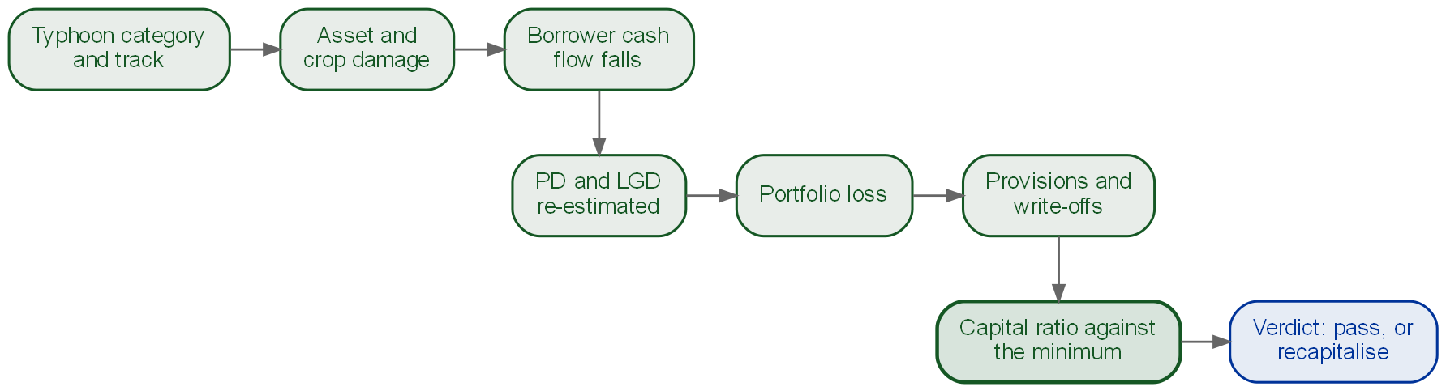
The whole case on one page: eight steps from the typhoon’s category and track to a verdict on solvency.
The case builds the assessment in four analytical steps that mirror the module.
Step 1, hazard. Fit a Generalized Extreme Value distribution to historical maximum wind speeds (or flood depths),
$$F(v)=\text{exp}​\left\{-{\left[1+ξ\left({v-μ}/σ\right)\right]}^{-1/ξ}\right\},$$
where a positive shape parameter $ξ$ indicates heavy tails, and invert it to obtain return-period hazard levels.
Step 2, loss. Map hazard to financial loss through exposure (insured building value by district) and a vulnerability damage curve (for example zero damage below 30 m/s rising to about 90 percent above 50 m/s), then simulate many synthetic years (a Monte Carlo of, say, 10,000 scenarios) to obtain a distribution of annual insured losses.
Step 3, tail risk. Summarize the tail with Value-at-Risk and Conditional Value-at-Risk,
$$VaR(α)=\text{min}\{L:P(\text{Loss}≤L)≥α\}, CVaR(α)=E[\text{Loss}∣\text{Loss}≥VaR(α)].$$
CVaR is the average of losses beyond the VaR threshold, so it captures how bad the tail is, not merely where it begins.
Step 4, capital and reinsurance. Compare capital to the tail estimate through a solvency ratio (total capital over required capital) and choose a reinsurance structure that holds the stressed solvency ratio above target at least cost.
Key concept: Indicative results. Worked through on the case’s synthetic loss dataset, the fitted distribution gives a 1-in-100-year insured loss of roughly $5 to $7 billion and a 1-in-250-year loss of about $10 to $15 billion. An assumed climate adjustment of plus 5 to 8 percent in intensity by 2050 lifts the 1-in-100-year figure to about $7 to $9 billion. Notice the asymmetry, which is the result worth taking away: a single-digit percentage shift in intensity moves the tail loss by far more than a single-digit percentage, because the damage relation is convex. A large insurer with $2.5 billion of capital against an OIC minimum of $1.5 billion has a comfortable solvency ratio in normal times, but a 1-in-100-year event (about $1 billion of net loss after reinsurance) can pull its post-event ratio down to the regulatory minimum, which is why reinsurance and capital buffers are the binding policy levers.

Teaching structure (4 phases, about 50 minutes, the middle of that range)
- Risk visualization (10 min). Plot the simulated annual-loss histogram; identify the 50th, 90th, and 99th percentiles; discuss how recent warmer years compare with the historical baseline.
- Capital adequacy (15 min). Given an insurer balance sheet, compute the solvency ratio, then recompute it after a 1-in-100-year loss and ask whether the insurer remains solvent.
- Reinsurance strategy (15 min). Compare excess-of-loss structures (for example transferring $1 billion at a 4 percent premium versus $3 billion at 7 percent versus no cover) and find the option that maintains solvency at least cost.
- Climate implications (10 min). Apply the climate-adjusted loss distribution and compare the new VaR with the baseline; debate whether regulators should require more capital now or wait for greater certainty.

Discussion questions
- Direct landfalls are rare enough that only a handful appear in the modern record. Is that sample adequate to fit an extreme-value distribution, and how sensitive is VaR to the distribution chosen?
- A 5 to 10 percent rise in intensity need not map to a 5 to 10 percent rise in VaR; why might the tail response be larger?
- If several Asian countries face major events at once, reinsurance capacity may be scarce; how should an insurer plan for tail risk if reinsurance is unavailable at the moment of crisis?
- Does an implicit government backstop after disasters cause insurers to underprice risk?
- How would you modify the loss model to capture compound events, a cyclone arriving during the monsoon?
- Catastrophe cover reaches only part of the population, and the poorest are the least insured. Should insurance be mandated or remain voluntary?
Teaching note. Lead with the headline tension: Thailand’s signature catastrophe is flooding, not direct typhoon landfall, yet the tail-risk machinery is identical, which lets you connect this case straight back to the Chapter 4 CVaR decomposition and the Chapter 5 capital identity. Pre-empt four common misconceptions: that VaR is the worst case (it is the 99th percentile; CVaR describes the tail beyond it), that more reinsurance is always better (it is costly, so the optimum trades cost against solvency), that history predicts the future (climate change shifts the distribution, so non-stationarity must be modelled), and that capital equals payout capacity (an insolvent insurer pays policyholders only partially). The simplest live exercise is the solvency calculation in Phase 2; the full extreme-value fit and reinsurance optimization (with runnable Python and Stata snippets in the source case file) are the PhD extension. A simplified synthetic loss dataset is the only material participants need.

Module 4 Assessment
This assessment combines fifteen multiple-choice questions covering all six lessons with one applied exercise that builds on the Appendix A case. The grading rubric and an answer key follow. The micro-credential assessment is coursework-based; this appendix can be used as a formative check or as the basis for a graded assignment.

Part 1: Multiple-choice questions
Select one answer per question. The answer key is at the end of this appendix.
- Which of the following is NOT one of the three top-level categories of climate-related financial risk?
(a) Physical (b) Transition (c) Liability (d) Regulatory
- For ASEAN banks, which transmission channel is dominant?
(a) Credit (b) Market (c) Operational (d) Liquidity
- Double materiality, as in the EU CSRD, requires assessing:
(a) Only how climate affects the firm (b) Only how the firm affects climate (c) Both directions (d) Neither
- Which TCFD pillar is the operational core for risk professionals?
(a) Governance (b) Strategy (c) Risk Management (d) Metrics and Targets
- The TNFD nature risk-assessment process is called:
(a) LEAP (b) PCAF (c) WACI (d) SCORE
- In Module 4, TCFD and TNFD are used for risk assessment; their disclosure requirements belong to:
(a) Module 1 (b) Module 3 (c) Module 5 (d) Basel III
- The four NGFS scenario categories are Orderly, Disorderly, Too little too late, and:
(a) Hot House World (b) Paris-Aligned (c) Business as Usual (d) Net Negative
- For a typical ASEAN portfolio, the worst-case scenario is usually:
(a) Orderly (b) Disorderly (c) Hot House World (d) Net Zero 2050
- If a sector has climate sensitivity $β=1.5$ and the scenario GDP impact is minus 8 percent, the modelled rise in default probability $ΔPD=- β×ΔGDP$ is:
(a) 4 points (b) 8 points (c) 12 points (d) 1.5 points
- For a bank, the overwhelming majority of emissions fall under:
(a) Scope 1 (b) Scope 2 (c) Scope 3 Category 15 (financed emissions) (d) Scope 3 Category 1
- WACI normalizes a company’s carbon intensity by its:
(a) Assets (b) Revenue (c) Emissions (d) Market capitalization
- In the Vietnam case, which sector carried the larger Climate VaR?
(a) Coal and power (transition) (b) Agriculture (physical) (c) Services (d) Manufacturing
- The single headline output of a climate stress test is the:
(a) WACI (b) Implied Temperature Rise (c) Post-stress capital adequacy ratio (d) Financed-emissions total
- The Basel III minimum CAR including the capital conservation buffer is:
(a) 8.0% (b) 10.5% (c) 4.5% (d) 13.0%
- The integrated risk identity used in the capstone is Risk equals Hazard times Exposure times:
(a) Vulnerability (b) Insurance (c) Emissions (d) Volatility

Part 2: Applied exercise (tied to Appendix A)
A Thai non-life insurer reports total usable capital of $2.5 billion against an OIC required minimum of $1.5 billion.
- Compute the insurer’s solvency ratio in normal conditions.
- A 1-in-100-year catastrophe produces an industry insured loss of about $6 billion; after reinsurance the insurer’s net share is about $1 billion. Compute the post-event capital and the post-event solvency ratio, and state whether the insurer remains above the minimum.
- The insurer is offered two excess-of-loss reinsurance structures: Option A transfers $1 billion of losses at a 4 percent premium, Option B transfers $3 billion at a 7 percent premium. Briefly argue which better balances cost against stressed solvency, and explain why buying maximum cover is not automatically optimal.
- A climate adjustment raises modelled intensity by 5 to 8 percent, lifting the 1-in-100-year loss from about $5 to $7 billion to about $7 to $9 billion. Discuss, in one paragraph, whether the regulator should require additional capital now or wait for greater certainty, referencing the deep-uncertainty argument from Chapter 3.

Grading rubric
Dimension | Excellent (4) | Competent (3) | Developing (2) | Beginning (1)
Understanding | Grasps causal logic deeply; identifies nuances | Understands main argument; minor gaps | Some confusion on mechanism | Incomplete understanding
Technical | Calculations correct; extensions sound | Reproduces results; minor issues | Approximate results; some errors | Incomplete or incorrect
Critical | Identifies multiple limitations; proposes fixes | Notes key limitations; reasonable fixes | Identifies some issues | Does not address limitations
Communication | Clear, concise, well structured | Generally clear; minor awkwardness | Somewhat unclear | Confusing

Answer key (Part 1)
1:(d), 2:(a), 3:(c), 4:(c), 5:(a), 6:(c), 7:(a), 8:(c), 9:(c), 10:(c), 11:(b), 12:(b), 13:(c), 14:(b), 15:(a).
Part 2 worked answers. (1) Solvency ratio $=2.5/1.5≈1.67$, that is about 167 percent. (2) Post-event capital $=2.5-1.0=1.5$ billion, so the post-event ratio is $1.5/1.5=1.0$, exactly at the minimum; the insurer is solvent but with no buffer. (3) Either option can be defended; the key reasoning is that reinsurance premiums are a certain cost paid every year against an uncertain tail loss, so the optimum holds the stressed solvency ratio above target at least expected cost rather than maximizing cover. (4) A defensible answer notes that under deep uncertainty point probabilities are unreliable, so waiting for certainty is itself a choice with tail consequences; pre-funding capital or reinsurance buys robustness across scenarios.
The answers are collected here, apart from the questions, so they can be withheld when the assessment is handed to participants.

Reading List and References
This curated list collects the sources cited across the six lessons and the appendices, grouped by theme. It is a reading guide rather than an exhaustive bibliography; every item appears in the source lecture decks or case studies for this module. Standards and framework documents are listed first because they are the primary references for practice.

Standards and frameworks
- TCFD (2017). Final Report: Recommendations of the Task Force on Climate-related Financial Disclosures. Financial Stability Board.
- TCFD (2021). Implementing the Recommendations of the TCFD. Financial Stability Board.
- TNFD (2023). Recommendations of the Taskforce on Nature-related Financial Disclosures, v1.0.
- ISSB (2023). IFRS S2: Climate-related Disclosures. International Sustainability Standards Board.
- BCBS (2022). Principles for the Effective Management and Supervision of Climate-Related Financial Risks. Basel Committee on Banking Supervision.
- PCAF (2022). The Global GHG Accounting and Reporting Standard for the Financial Industry (2nd ed.). Partnership for Carbon Accounting Financials.
- 2DII (2024). PACTA Methodology Documentation. 2 Degrees Investing Initiative.
- ASEAN Taxonomy Board (2023). ASEAN Taxonomy for Sustainable Finance, Version 2.

Scenarios and climate modeling
- NGFS (2024). NGFS Scenarios: narratives and key findings. Results version 5.0, released November 2024 (Phase V). The version matters: the set is revised roughly every year, and scenario names have been retired and added between vintages.
- van Vuuren, D. P., et al. (2011). The representative concentration pathways: an overview. Climatic Change, 109, 5 to 31.
- Riahi, K., et al. (2017). The Shared Socioeconomic Pathways and their implications. Global Environmental Change, 42, 153 to 168.
- Bolton, P., et al. (2020). The Green Swan: Central Banking and Financial Stability in the Age of Climate Change. BIS and Banque de France.
- IPCC (2023). AR6 Synthesis Report: Climate Change 2023.
- Nordhaus, W. (2017). Revisiting the social cost of carbon. PNAS, 114(7), 1518 to 1523.
- Weitzman, M. (2009). On modeling and interpreting the economics of catastrophic climate change. Review of Economics and Statistics, 91(1), 1 to 19.
- Howard, P., and Sterner, T. (2017). Few and not so far between: a meta-analysis of climate damage estimates. Environmental and Resource Economics, 68(1), 197 to 225.
- IEA (2024). World Energy Outlook 2024. International Energy Agency.

Carbon metrics and asset pricing
- Bolton, P., and Kacperczyk, M. (2021). Do investors care about carbon risk? Journal of Financial Economics, 142(2), 517 to 549.
- Sautner, Z., van Lent, L., Vilkov, G., and Zhang, R. (2023). Firm-level climate change exposure. Journal of Finance, 78(3), 1449 to 1498.
- Dietz, S., Bowen, A., Dixon, C., and Gradwell, P. (2016). Climate value at risk of global financial assets. Nature Climate Change, 6, 676 to 679.

Stress testing and systemic risk
- ECB (2022). 2022 Climate Risk Stress Test. European Central Bank.
- BoE (2022). Results of the 2021 Climate Biennial Exploratory Scenario (CBES). Bank of England.
- Acharya, V., Berner, R., Engle, R., et al. (2023). Climate stress testing. Annual Review of Financial Economics, 15, 291 to 326.
- Battiston, S., Mandel, A., Monasterolo, I., Schuetze, F., and Visentin, G. (2017). A climate stress-test of the financial system. Nature Climate Change, 7, 283 to 288.
- Krueger, P., Sautner, Z., and Starks, L. T. (2020). The importance of climate risks for institutional investors. Review of Financial Studies, 33(3), 1067 to 1111.
- UNEP FI (2024). Climate Risk Stress Testing for Banks: A Practical Guide. UN Environment Programme Finance Initiative.

ASEAN, adaptation, and methods
- ADB (2023). Southeast Asia’s Climate Risk and Adaptation Finance. Asian Development Bank.
- UNEP (2023). Adaptation Gap Report 2023. UN Environment Programme.
- World Bank (2022). Philippines Country Climate and Development Report.
- IPCC (2022). Climate Change 2022: Impacts, Adaptation and Vulnerability, AR6 Working Group II.
- GCF (2024). Status of Approved Projects and Programmes. Green Climate Fund.
- Cevik, S., and Jalles, J. T. (2022). This changes everything: climate shocks and sovereign bonds. Energy Economics, 107, 105856.
- Kelejian, H. H., and Prucha, I. R. (1998). A generalized spatial two-stage least squares procedure for estimating a spatial autoregressive model with autoregressive disturbances. The Journal of Real Estate Finance and Economics, 17(1), 99 to 121.
- Coles, S. G. (2001). An Introduction to Statistical Modeling of Extreme Values. Springer.
- McNeil, A. J., Frey, R., and Embrechts, P. (2015). Quantitative Risk Management (2nd ed.). Princeton University Press.

Regulatory sources and data
- Bank of Thailand (2024). Climate Risk Assessment of the Thai Banking System.
- MAS (2022). Guidelines on Environmental Risk Management for Banks. Monetary Authority of Singapore.
- BSP (2020). Sustainable Finance Framework (Circular No. 1085). Bangko Sentral ng Pilipinas. (Circular No. 1149, 2022, separately covers sustainability in banks’ investment activities.)
- SBV (2024). Green Credit Growth Guidelines / Green Finance Roadmap. State Bank of Vietnam.
- SEADRIF (2023). Southeast Asia Disaster Risk Insurance Facility: Annual Report. World Bank.
- NGFS Scenario Explorer: data.ene.iiasa.ac.at/ngfs. World Bank Climate Change Knowledge Portal: climateknowledgeportal.worldbank.org.
- EM-DAT (2025). International Disaster Database. CRED, UCLouvain. ND-GAIN (2023). Country Index. University of Notre Dame.

Works cited
[1] BCBS (2011). Basel III: A global regulatory framework for more resilient banks and banking systems, revised June 2011. Basel Committee on Banking Supervision, Annex 1: Calibration of the capital framework.
[2] BCBS (2022). Principles for the effective management and supervision of climate-related financial risks. Basel Committee on Banking Supervision, June 2022.
[3] Bangko Sentral ng Pilipinas. Report on Recent Trends in the Philippine Financial System, Issue No. 2024-03.
[4] Battiston, S., Mandel, A., Monasterolo, I., Schuetze, F., and Visentin, G. (2017). A climate stress-test of the financial system. Nature Climate Change, 7, 283 to 288.
[5] Bolton, P. and Kacperczyk, M. (2021). Do Investors Care about Carbon Risk? Journal of Financial Economics 142(2), 517-549. NBER Working Paper 26968.
[6] Bolton, P. and Kacperczyk, M. (2023). Global Pricing of Carbon-Transition Risk. The Journal of Finance 78(6), 3677-3754. NBER Working Paper 28510.
[7] Bolton, P., Despres, M., Pereira da Silva, L. A., Samama, F., and Svartzman, R. (2020). The green swan: central banking and financial stability in the age of climate change. Bank for International Settlements.
[8] CDP (2021). Finance sector’s funded emissions over 700 times greater than its own. Press release, 28 April 2021.
[9] Carney, M. (2015). Breaking the tragedy of the horizon: climate change and financial stability. Speech at Lloyd’s of London, 29 September 2015. Bank of England. Full text: BIS Review r151009a.
[10] Climate Policy Initiative (2023). Global Landscape of Climate Finance 2023. Press release, November 2023.
[11] Dietz, S., Bowen, A., Dixon, C., and Gradwell, P. (2016). Climate value at risk of global financial assets. Nature Climate Change, 6, 676 to 679.
[12] European Central Bank (2022). 2022 climate risk stress test. ECB Banking Supervision, July 2022.
[13] European Central Bank (2022). ECB banking supervision launches 2022 climate risk stress test. Press release, 8 July 2022.
[14] European Commission, Taxation and Customs Union. Carbon Border Adjustment Mechanism.
[15] Krueger, P., Sautner, Z., and Starks, L. T. (2020). The Importance of Climate Risks for Institutional Investors. Review of Financial Studies, 33(3), 1067 to 1111. ECGI Finance Working Paper.
[16] Milieudefensie et al. v. Royal Dutch Shell plc, Hague District Court, 26 May 2021. Sabin Center Climate Change Litigation Databases.
[17] Munich Re (2024). Natural disaster figures 2023. Media information, 9 January 2024.
[18] NGFS (2024). NGFS Scenarios: narratives and key findings, Net Zero 2050 scenario narrative. Results version 5.0, released November 2024 (Phase V).
[19] NGFS (2024). NGFS Scenarios: narratives and key findings. Box 1, NGFS Scenario framework, page 9. Results version 5.0, released November 2024 (Phase V).
[20] NGFS. Origin and Purpose. Network of Central Banks and Supervisors for Greening the Financial System.
[21] PAGASA. Tropical Cyclone Information. Philippine Atmospheric, Geophysical and Astronomical Services Administration, DOST.
[22] Setzer, J. and Higham, C. (2023). Global trends in climate change litigation: 2023 snapshot. Grantham Research Institute, LSE.
[23] TCFD (2017). Recommendations of the Task Force on Climate-related Financial Disclosures. Final Report, June 2017. Financial Stability Board.
[24] TNFD (2023). Recommendations of the Taskforce on Nature-related Financial Disclosures. September 2023.
[25] World Bank (2012). Thai Flood 2011: Rapid Assessment for Resilient Recovery and Reconstruction Planning.
[26] World Bank (2022). New World Bank Group Report Proposes Path for Vietnam to Address Climate Risks. Press release, 1 July 2022.

Key Terms and Acronyms
Module 4 is acronym-dense. This reference collects the abbreviations used across the chapters and defines the handful of terms that carry the most analytical weight. It is meant to be consulted while reading the chapters, not read straight through.

Acronyms
Acronym | Expansion
TCFD | Task Force on Climate-related Financial Disclosures
TNFD | Taskforce on Nature-related Financial Disclosures
NGFS | Network for Greening the Financial System
PCAF | Partnership for Carbon Accounting Financials
WACI | Weighted Average Carbon Intensity
VaR | Value-at-Risk
CVaR | Climate Value-at-Risk (in this module; elsewhere Conditional VaR)
ITR | Implied Temperature Rise
GHG | Greenhouse Gas
EVIC | Enterprise Value Including Cash
PD | Probability of Default
LGD | Loss Given Default
EAD | Exposure at Default
EL | Expected Loss
CAR | Capital Adequacy Ratio
RWA | Risk-Weighted Assets
ICAAP | Internal Capital Adequacy Assessment Process
ERM | Enterprise Risk Management
BCBS | Basel Committee on Banking Supervision
ISSB | International Sustainability Standards Board
CSRD | Corporate Sustainability Reporting Directive (EU)
SFDR | Sustainable Finance Disclosure Regulation (EU)
CBAM | Carbon Border Adjustment Mechanism (EU)
IAM | Integrated Assessment Model
RCP | Representative Concentration Pathway
SSP | Shared Socioeconomic Pathway
NZE / APS / STEPS | IEA Net Zero Emissions / Announced Pledges / Stated Policies scenarios
NDC | Nationally Determined Contribution
ND-GAIN | Notre Dame Global Adaptation Initiative country index
GCF | Green Climate Fund
LEAP | Locate, Evaluate, Assess, Prepare (TNFD process)
EVT | Extreme Value Theory
DiD | Difference-in-Differences
IV | Instrumental Variables
ECB / BoE | European Central Bank / Bank of England
MAS / BOT / BSP / SBV | Monetary Authority of Singapore / Bank of Thailand / Bangko Sentral ng Pilipinas / State Bank of Vietnam
SEADRIF | Southeast Asia Disaster Risk Insurance Facility

Key terms
Physical risk
Financial risk from the climate itself, split into acute (event-driven) and chronic (gradual) hazards.
Transition risk
Financial risk from the shift to a low-carbon economy, through policy, technology, market, reputation, and behavioral channels.
Liability risk
Financial risk from litigation, adaptation failure, and greenwashing claims.
Financed emissions
The share of a borrower’s emissions attributed to a lender, the dominant (Scope 3, Category 15) component of a bank’s footprint.
Double materiality
The requirement to assess both how climate affects the firm (financial materiality) and how the firm affects climate (impact materiality).
Climate Value-at-Risk
The expected loss of portfolio value under a specified climate scenario, decomposed into physical and transition components.
Stranded asset
An asset that suffers an unanticipated or premature write-down due to climate policy, technology, or market change.
Transmission channel
The pathway (credit, market, operational, liquidity) by which a climate event becomes a financial loss.

Acknowledgments
This module was developed by the University of Twente as Module 4 of the GREEN FINANCE curriculum, under Work Package 3 of the Erasmus+ Capacity Building in Higher Education project GREEN FINANCE (Grant 101237817). It draws on the module structure and allocation agreed by the project consortium.

Use of generative AI
Generative AI was used as a writing and research assistant in preparing this module. The tool was Claude (Anthropic), versions Opus 4.8 and Opus 5, used from July 2026 to the submission of this module on 11 September 2026.
Its use was confined to the following purposes:
- idea generation and brainstorming on module structure and worked examples;
- language editing of author-specified content;
- literature classification and organisation of the reading list;
- coding assistance for the chart, data-processing, and document-build scripts;
- interactive literature searching using AI-enhanced search tools.
The authors specified and reviewed the content of this module. Every cited source was checked against the original publication, and every figure states its provenance on its own face, distinguishing sourced from derived values and from illustrative teaching assumptions; figures whose data could not be sourced were withdrawn rather than published. The authors remain fully responsible for the originality, accuracy, integrity, references, and conclusions of the material.
The module is released under the Creative Commons Attribution 4.0 International licence stated on the cover, so it may be reused, adapted, and redistributed with attribution to the University of Twente and the GREEN FINANCE project.

